Lesson 25

Politics

La política

In this Spanish lesson you learn to
- Discuss important world issues and possible solutions
- Understand and express actions or ideas that are conditional upon each other (part 2)
- Give and ask for reasons for or against an idea
- 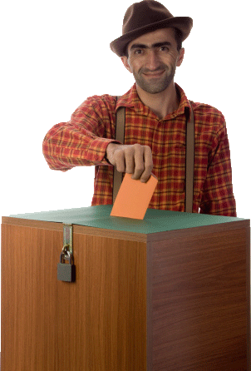
Vocab Canvas

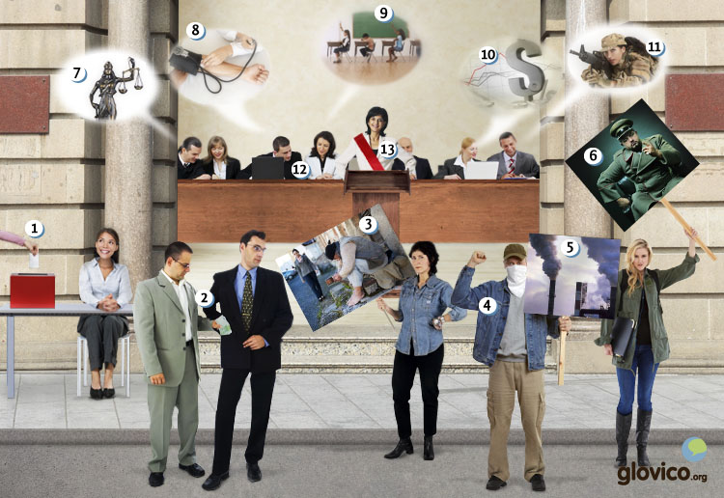

Talking

At the UN
You are the representative of a small human rights NGO at the UN and are trying to convince the UN staff that you should be given access to a meeting where issues will be discussed for whom you have special expertise and local knowledge.

Thinking
- Think about ways to convince the staff member to give you access.
- Consider how the meeting might me different if your expertise is heard there.

Talking
- Discuss the matter with the staff member.
- Point out to him what effect your insights would have.

Optional
- Discuss the human rights issue with your teacher that you internationally consider most pressing at the moment.

Story telling

Writing

Write yet another blog post
Write about the current global politics. Consider economy, ecology, human rights as well as inequalities. What do you consider the most important issue? And what could be done about it?

Preparation
- Think about a global issue.
- Consider all the grammatical structures that you have learnt so far.

Writing
- Describe the global issue, its roots, potential solutions and the public view of that issue.
- Use every grammatical structure that you have learnt in this course at least once.

Review
- Check your spelling and review your grammar.
- Once you are happy with the letter, send it to your teacher so he or she can review it.

Reading

¿Por quién votas?
Después de la corte suprema llamó a elecciones los candidatos arrancan sus campañas electorales. En las primeras encuestas dos candidatos salen como favoritos: el alcalde de Puerto Marina, candidato de la Derecha que gobierna el país, y el candidato del nuevo movimiento popular que se formó el año pasado. Hoy el candidato del movimiento popular destaca los aspectos importantes de su programa electoral.
"Buenos días mis amigos.
¿Están harto de los políticos que mejoran sobre todo su vida y las vidas de sus parientes? ¿Buscan un candidato que represente sinceramente al pueblo? ¿Dudan también que la Derecha haya cumplido con sus promesas?
Pues, les ofrezco una alternativa, yo soy el candidato del movimiento "Sinceri". Ya tengo el apoyo de una grande parte de nuestra populación y hoy quería explicarles mi programa. Si gano esas elecciones, llevaré a cabo las siguientes promesas:
- Aumentaremos la tasa de empleo en el país.
- Mejoraremos el apoyo y la formación para los jóvenes que estén en paro.
- Incluiremos a la asistencia médica todas personas mayores de 60 años y ofreceremos un seguro médico a precios razonables a toda la populación.
- Cambiaremos el presupuesto nacional para aumentar los gastos para la educación, la salud y la protección del medio ambiente. Reduciremos los gastos para el ejército y subiremos los impuestos para cualquiera que gane más de 200.000 euros.
Muchas gracias para su atención."

¿Ya has votado?
Según las encuestas el candidato de la Derecha tenía una pequeña ventaja sobre el candidato del movimiento popular. Pero ahora parece que el candidato del movimiento popular ha ganado terreno. Vamos a saber los resultados oficiales dentro de una hora. Hasta entonces hablaremos con algunos electores.
"Si hubiera existido el movimiento popular antes, la mayoría del país habría votado por su candidato."
"Dudo que el candidato del movimiento popular tenga éxito. Nadie que conozca, votaría por él."
"Si ganara el candidato del movimiento popular, tendríamos una crisis pronto. Gastaría demasiado por los programas sociales."

Culture

Narcotráfico
Some of the major political issues in Central America these days are drug-related. An estimated 1% of the global economy are drugs and Central America is a key producer, particularly for Cocaine. And while Coca has a longstanding rooting in the Andean cultures and is casually chewed in several countries in that area, it is illegal in Northern America, where is typically not consumed in its traditional form but as much more potent chemical derived from the plant: cocaine.
And what makes the issue so complex is the diversity of the interests connected to it: the farmer producing the plant and the drug producer making cocaine out of coca leaves who make a living from it (and sometimes get insanely rich), indigenous consumers and people addicted to cocaine. On top of that obviously there are political interests from the US government as well as the various Latin American governments.
While it is hard to identify right solutions in such a complex problem it is good to closely analyze the current situation. One piece of the puzzle is Northern part of Mexico where most of the drugs coming from Latin America to the US is trafficked through. These regions have seen a tremendous increase in violence in the recent years as the political measures against drug trafficking become harder (e.g. Mexico now draws upon its army to fight drug-related crime instead of the police because it feels that the police cannot be trusted). In Ciudad Juarez which is in Mexico just across from El Paso in Texas in 2010, some 3,100 people were killed in drug-related violence. And that is an awful lot for a city with a little more than a million inhabitants. Yet, the violence has spreadt since then and can be found all throughout the country in the meantime.
It seems like the war on drugs has really become a war in the meantime - with all the collateral damage that such a war brings along. Let's hope nobody makes that business as usual.

Grammar

More on the subjunctive
So far you have learnt to use the present tense form of the subjunctive. Now you learn to use the subjunctive in other tenses.

Subjunctive imperfect
The subjunctive imperfect for all regular and irregular verbs is formed by taking the third person plural of the preterit without the ending -ron and adding the following endings.
 | hablar (hablaron) | beber (bebieron) | vivir (vivieron)
yo | habla + ra | bebie + ra | vivie + ra
tú | habla + ras | bebie + ras | vivie + ras
él, ella, usted | habla + ra | bebie + ra | vivie + ra
nosotros/as | hablá + ramos | bebié + ramos | vivié + ramos
vosotros/as | habla + rais | bebie + rais | vivie + rais
ellos, ellas, ustedes | habla + ran | bebie + ran | vivie + ran
Note that the last vowel before the ending is emphasized and all first person plural forms carry an accent.
All irregular verbs are formed by taking the third person plural preterit, removing the -ron and adding the subjunctive imperfect endings. Take a look at the following table to see how this works for a number of irregular verbs.
Infinitive | Third person plural preterit | First person singular imperfect subjunctive
creer | creyeron | creyera
decir | dijeron | dijera
estar | estuvieron | estuviera
haber | hubieron | hubiera
ir | fueron | fuera
leer | leyeron | leyera
poder | pudieron | pudiera
poner | pusieron | pusiera
querer | quisieron | quisiera
saber | supieron | supiera
ser | fueron | fuera
tener | tuvieron | tuviera
traer | trajeron | trajera
venir | vinieron | viniera
The imperfect subjunctive is required under similar conditions as the subjunctive present tense. When a sentence in the past expresses doubt, feelings, opinions and similar subjective feelings, you need to use the subjunctive imperfect.
Siento que no pudieras despedirte. | I’m sorry that you couldn’t say goodbye.
Me pidieron que viniera temprano. | They asked me to come early.
Era improbable que tuviera éxito. | It was unlikely that he would be successful.

Subjunctive perfect
The subjunctive perfect is formed by taking the subjunctive present form of the auxiliary verb haber and the participle.
yo | haya | hablado
tú | hayas | hablado
él, ella, usted | haya | hablado
nosotros/as | hayamos | hablado
vosotros/as | hayáis | hablado
ellos, ellas, ustedes | hayan | hablado
The present perfect subjunctive is used when the main clause expresses doubt, emotion, a wish or other subjective expression about the subordinate clause. Typically the verb in the main clause is in the present tense, while the subordinate clause expresses an event or action that has just finishes or is still ongoing.
Dudo que hayan llegado. | I doubt that they have arrived.
Espero que hayáis encontrado la casa. | I hope that you found the house.

Conditional sentences II
You have previously learnt that the conditional sentences that express an event that the speaker believes to happen, are formed with si + indicative present tense for the condition, and future or present tense for the resultant clause.
Si quieres, iremos al cine. | If you want, we will go to the movies.
Si tienen hambre, vamos al restaurante. | If they are hungry, we will go to the restaurant.
Now you learn to express statements that express conditions that are unlikely or contrary to current knowledge. You use the si + imperfect subjunctive for the condition, and the conditional for the resultant clause.
Si supiera chino, viajería a China. | If I knew Chinese, I would travel to China.
Sería más interesante, si tuvieras tus gafas. | It would be more interesing if you had your glasses.
Si fuera a Chile, visitoría mis amigos. | If I traveled to Chile, I would visit my friend.

- See more at: http://www.glovico.org/syllabus/Spanish/lesson25/grammar#sthash.hbeoNKRs.dpuf

Vocabulary
Spanish | English
el partido | (political) party
la ley | law
la Izquierda | left wing
la Derecha | right wing
gobernar | to govern
el parlamento | parliament
la democracia | democracy
la socialdemocracia | social democracy
el capitalismo | capitalism
la monarquía | monarchy
el comunismo | communism
el fascismo | fascism
el golpe de Estado | coup (d’état)
el movimiento popular | grass-roots movement
la revolución | revolution
la elección | election
el/la político/a | politician
la campaña electoral | election campaign
el debate | debate
el candidato | candidate
el voto por correo | absentee vote
el fraude | fraud
la encuesta | survey
el derecho | right
el ministro | Minister
el ministerio | Ministry
el Rey | King
la Reina | Queen
llamar a elecciones | to call an election
el empleado público | civil servant
liberal | liberal
la oposición | opposition
el/la ciudadano/a | citizen
los impuestos | taxes
la corte suprema | supreme court
la mayoría | majority
la minoría | minority
apoyar | to support
las armas | weapons
el ejército | military
el/la alcalde/sa | mayor
combatir | to fight, to combat
controlar | to control
resolver | to solve
la inflación | inflation
arrancar | to pull off, to set off
destacar | to emphasize
estar harto/a de | to be fed up with
el pariente | relative
sincero/a | honest
cumplir (con) | to fulfill, to carry out
la promesa | promise
la alternativa | alternative
llevar a cabo | to carry out
siguiente | following
incluir | include
la asistencia médica | health care
razonable | reasonable
la salud | health
la ventaja | advantage
ganar terreno | to catch up
el resultado | result
el programa social | social welfare program

