Lesson 24

Nature

La naturaleza

In this Spanish lesson you learn to
- Discuss environmental issues
- Express actions that will have happened in future
- Express actions that should have happened in the past
- Ask someone not to do something
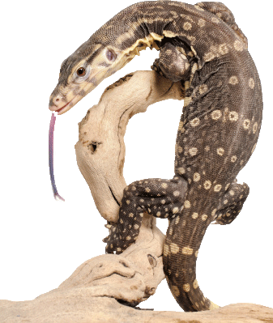
Vocab Canvas

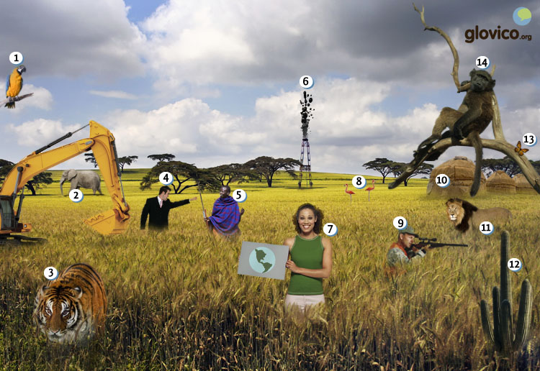

Talking

Eco-Volunteering
You are volunteering as a guard in a national park over the summer. One evening you encounter a group of youngsters slightly drunk who are about to pitch a tent (which is strictly forbidden) and light up a BBQ (which is even stricter forbidden). You give them a lecture about the degradation of nature.

Thinking
- Think about how to express your anger.
- Make a mental list of the things that could happen if the fire spreads.

Talking
- Express your anger and scold the youngsters.
- Tell them about all the things that could happen because of their irresponsibility.

Optional
- Throw them out of the national park.

Story telling
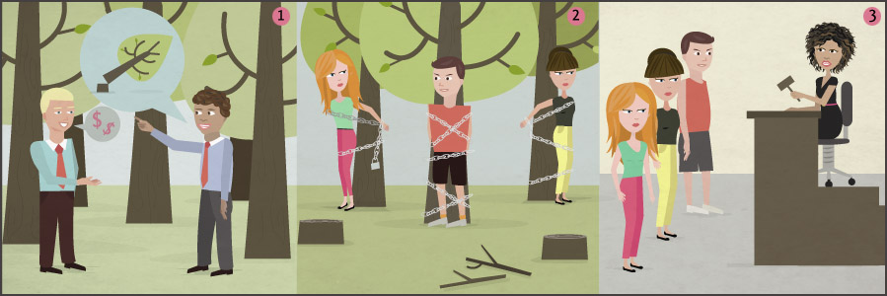

Writing

Write a petition to the municipality
Environmental degradation has recently become a big concern for you. You now decide to take action and write a letter to the municipality about that one thing in terms of environmental degradation that troubles you most. Include what you consider to be going wrong, the troubles that this cause, the action that be taken as well as the positive outcomes that this should have.

Preparation
- Think about an ecological issue that troubles you.
- Consider how to describe what will have happened in the future.

Writing
- Describe your ecological concerns as well as potential solutions.
- Write about what your kids 5o years from now will want the current municipality to have done.

Review
- Check your spelling and review your grammar.
- Once you are happy with the letter, send it to your teacher so he or she can review it.

Reading

¿Qué habrás hecho?
Pedro y Paula son dos estudiantes que realizan proyectos sociales aparte de sus estudios. Hoy hablan sobre sus actividades.
Pedro: Empecé a proteger el medio ambiente hace 3 años, después de ver la contaminación del bosque cerca de la ciudad durante una visita. En diciembre habremos traído más de 1000 niños al bosque para aprender cómo se conserva y cómo ellos pueden ayudarnos.
Paula: Me habría encantado dedicarme a la ecología también, pero en mis estudios veía sobre todo el efecto de la pobreza sobre el desarrollo de los niños. Fundé una organización que ayuda a los niños para que aprendan a leer. Este año habremos distribuido 10000 libros a familias pobres.
Pedro: ¿Las escuelas han perdido su presupuesto de la ciudad?
Paula: Es verdad, hace dos años lo redujeron profundamente. Es improbable que lo suban en los próximos años, pero me encanta que tengamos tanto apoyo de los padres, profesores, donantes y sobre todo de los editoriales. Nos rebajan los libros por un 90% y a veces nos los regalan.
Pedro: Me encanta que tengas tanta energía para tu proyecto. Me parece que será lo más importante para tener éxito.
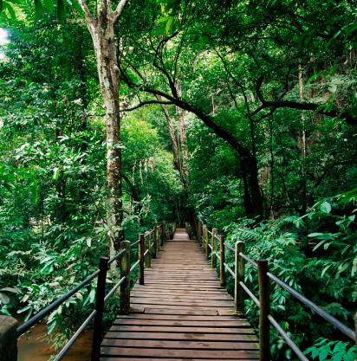

Madidi
El parque nacional Madidi está situado en el noroeste de La Paz, Bolivia. Su terreno es montañoso con una elevación de 180 metros a 5760 metros. Se caracteriza por su gran biodiversidad, en flora y en fauna. Se pueden observar pumas, jaguares, monos, boas y muchos otros reptiles, aves y peces.
Para conservar la ecología del parque, es muy importante que los turistas observen las reglas del parque nacional
- No haga fuego fuera de los sitios de camping
- Está prohibido acampar fuera de los campings
- No tire basura, toda basura debe ser retirada del parque nacional
- Circule por los senderos y no abandone los caminos
- No dañe ni moleste a flora y fauna

Culture

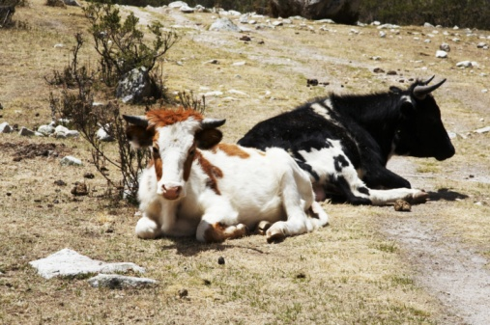

Sistema Biabolsa
The management of organic waste is a big challenge in Middle America, which makes it a global problem considering that Central America is home to about a third of the animals found worldwide. With that in mind it becomes very important to develop solutions that are adapted to the local culture in order to protect the global ecosystem.
One very simple solution that tries to tackle this problem is the "Sistema Biabolsa" which attempts to change the habits of small-scale farmers in Mexico by promoting biodigester systems. Such systems allow the farmers to produce an odorless gas from their animal waste which can then be used for cooking and heating as well as an organic fertilizer. In addition to that product itself education is very important to Biobolsa to increase the understanding of sustainable farming and help the small farmers overcome poverty cycles.
Particularly the latter seems to be an essential component of the system as ecological conflicts oftentimes go hand in hand with social issues. And if people have to make a living from their environment one can hardly expect them to change their habits unless it is crystal-clear that they won't lose their income due to that change.

Grammar

Express what will have happened: Future perfect
The future perfect is formed with the future of the auxiliary verb haber plus the past participle.
yo | habré | tomado
tú | habrás | tomado
él, ella, usted | habrá | tomado
nosotros/as | habremos | tomado
vosotros/as | habréis | tomado
ellos, ellas, ustedes | habrán | tomado
The future perfect expresses actions that will have happened at some future point.
Mañana lo habré terminado. | By tomorrow I will have finished it.
El año que viene habremos comprado un nuevo coche. | By next year we will have bought a new car.

Express what should have happened: Conditional perfect
The conditional perfectis formed by using the conditional of the auxiliary verb haber and the past participle.
yo | habría | tomado
tú | habrías | tomado
él, ella, usted | habría | tomado
nosotros/as | habríamos | tomado
vosotros/as | habríais | tomado
ellos, ellas, ustedes | habrían | tomado
The conditional perfect is used to express an action that should have or would have occurred, but in the end did not.
Habría limpiado la cocina, pero al final fui a la playa. | I should have cleaned the kitchen, but instead I went to the beach.
Me habría gustado llamarte, pero no tenía mi móvil. | I would have liked to call you, but I didn’t have my mobile.

More on commands: imperative
You have previously learnt how to give commands to an individual (informally and formally), to a group of people (informally and formally) and as part of a group of people. So far, all the commands were positive, now you learn negative commands.

Negative commands
The negative imperative is always formed by using no and the subjunctive form of the verb.
 | Subjunctive | Negative imperative
-ar verbs | tú hables | ¡No hables!
 | usted hable | ¡No hable!
 | vosotros habléis | ¡No habléis
 | ustedes hablen | ¡No hablen!
-er verbs | tú bebas | ¡No bebas!
 | usted beba | ¡No beba!
 | vosotros bebáis | ¡No bebáis!
 | ustedes beban | ¡No beban!
-ir verbs | tú escribas | ¡No escribas!
 | usted escriba | ¡No escribas!
 | vosotros escribáis | ¡No escribáis!
 | ustedes escriban | ¡No escriban!
You use the negative imperative to express negative commands or prohibitions.
¡No salgas con él! | Don’t go out with him.
¡No lo compren! | Don’t buy it!
¡No hable tan rápido! | Don’t talk so fast!

Vocabulary
Spanish | English
la naturaleza | nature
el medio ambiente | environment
la ecología | ecology
la conservación | conservation
la vida | life
la planta | plant
el animal | animal
el león | lion
el loro | parrot
el elefante | elephant
el tigre | tiger
el flamenco | flamingo
el nativo | native
la mariposa | butterfly
el/la cazador/a | hunter
el constructor | developer
el ser vivo | living creature
sobrevivir | to survive
el hábitat | habitat
la energía | energy
la energía solar | solar energy
la sequía | drought
la inundación | flood
el incendio | fire
el terremoto | earthquake
el tsunami | tsunami
el huracán | hurricane
la magnitud | magnitude
destruir | to destroy
la contaminación | pollution
el calentamiento global | global warming
proteger | to protect
contaminado/a | polluted
ecológico/a | ecological
la deforestación | deforestation
sostenible | sustainable
extinguirse | to extinguish
realizar | to do, to implement
aparte de | besides
el bosque | forest
sobre todo | above all
el efecto | effect
fundar | to found
distribuir | to distribute
reducir | to reduce
profundamente | deeply
el apoyo | support
el/la donante | donor
el editorial | publisher
rebajar | to reduce
el éxito | success
el parque nacional | national park
situar | to place, to locate
el terreno | ground, terrain
montañoso/a | mountainous
la elevación | elevation
caracterizarse (por) | to be characterized (by)
observar | to watch, to observe
el puma | puma
el jaguar | jaguar
el mono | monkey
la boa | boa
el reptil | reptile
el fuego | fire
acampar | to camp
el camping | campsite
el sendero | path
retirado/a | removed
la flora | flora
la fauna | fauna
dañar | to damage
abandonar | to leave
circular | to circulate, to move
el sitio | site

