Lesson 22

News

Las noticias

In this Spanish lesson you learn to
- Discuss recent political, economic and cultural issues
- Understand and discuss the media
- Talk about what will happen and what has happened
- Understand and express actions or ideas that are conditional upon each other (part 1)
Vocab Canvas

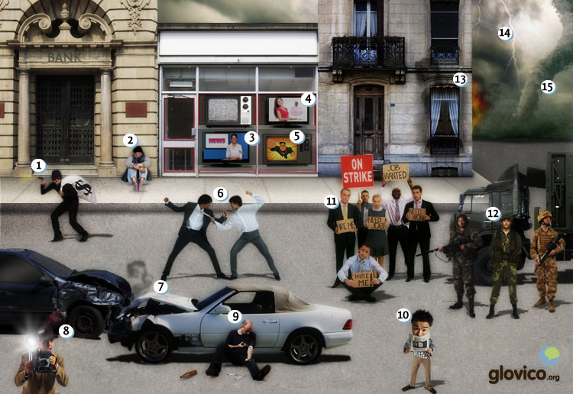

Talking

The news
Consider a recent issue in the country whose language you are learning and discuss it with your language teacher. Also consider how the media was presenting the issue.

Thinking
- Think about an issue in the country that recently caught a lot of attention.
- Think about your opinion on that matter and reflect how the media reported on it.

Talking
- Discuss the matter itself with your language teacher.
- Discuss the way that the media reported the issue with him/ her.

Optional
- Consider the way in which the media should have picked up the issue and how the public might have reacted differently then.

- See more at: http://www.glovico.org/syllabus/General/lesson22/talking#sthash.awGaL1Mw.dpuf Story telling
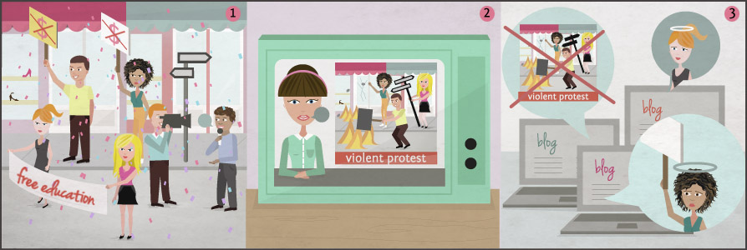

Writing

Write a blog post "If I ruled the world"
If you ruled the world what would the world look like? What would you change in terms of politics, global inequalities as well as the environment?

Preparation
- Think about all the things that you would change.
- Consider how to describe hypothetical events.

Writing
- Describe the world as it would look like if you ruled it.
- Write your text in conditional.

Review
- Check your spelling and review your grammar.
- Once you are happy with the blog article, send it to your teacher so he or she can review it.

Reading

El paro en España llega al 25%
Por la primera vez en la historia de España en 2012, uno de cada cuatro trabajadores está en paro. Con eso, España ha registrado la tasa de desempleo más elevada de toda la Unión Europea, seguida por Grecia con un 22%. Aún peor, más de la mitad de los jóvenes españoles se han quedado sin trabajo. Hemos hablado con una de ellas.
El mundo: Hola Carmen. ¡Cuéntanos sobre tu experiencia como joven española!
Carmen: Pues, cuando empecé a estudiar en 2007, la economía española estaba en auge. Elegí diseño gráfico porque siempre he sido muy creativa. Además me parecía una buena idea porque había mucho trabajo para los diseñadores.
El mundo: ¿Qué ha cambiado para ti ahora?
Carmen: Con la crisis es muy difícil encontrar trabajo. Los amigos de la universidad que ya se han graduado tienen muchos problemas. Sólo dos de cada diez trabajan en su asignatura. Y ellos solamente ganan 800 o 1000 euros cada mes. Con eso es casi imposible alquilar un apartamento. Por lo tanto siguen viviendo con sus padres. Este verano voy a terminar mis estudios. Antes espero hacer una práctica como diseñadora gráfica.
El mundo: ¿Qué harás después?
Carmen: Si no encuentro un trabajo en España durante medio año, iré a Alemania. Sé alemán de mi intercambio en Berlín hace dos años. Según mis amigos alemanes será más fácil encontrar un empleo en una agencia de publicidad por allí.
El mundo: ¡Mucha suerte para ti!

¿Qué dice el artículo?
Marina: ¿Has también leído el artículo del diario "El mundo" sobre el desempleo en España?
Juan: Aún no. ¿De qué se trata?
Marina: El titular dice que ya el 25% de los españoles no tienen trabajo. Según el artículo, el problema es peor para los jóvenes: más de la mitad no tiene trabajo en este momento.
Juan: ¿Qué harás? Si no puedo encontrar trabajo aquí en Guatemala después de mis estudios, iré a otro país. En Colombia o Chile habrá mucho trabajo.
Marina: No sé, a pesar de algunas dificultades que tenemos aquí, me importa estar cerca de mi familia. Pero en el artículo hicieron una entrevista con una chica, ella también piensa ir al extranjero para encontrar trabajo.
Juan: Sin embargo, me parece cansado depender de mi familia durante tanto tiempo.
Marina: Es verdad, no será fácil. Pero pienso que será mejor que los problemas que puedas tener en el extranjero. Escuché la radio el otro día, y en la emisora "Tiempo 89" estaban hablando en vivo con unos inmigrantes en Chile. Si no conoces las costumbres y normas de un país, será complicado integrarse a la sociedad.
Juan: ¡Deseo que encontremos empleo aquí!

Culture

Mafalda and Condorito
Some 50 years ago Malfalda and Condorito were born and have since become the protagonists of Latin American comic culture. Yet, they could not be more different: the Argentinian Malfalda is a smart and ironic young girl while the Chilean bird Condorito is very innocent sometimes even a bit clumsy. The former is critical of social injustices while the latter enjoys life and its small pleasures.

Malfalda
This 6 year old Argentinian lady has been described in various ways: amongst them as intelligent, liberal and thoughtful. She has the mission to change the world and with the help of her friends makes plans on how to make the planet a better place. Situated in a middle class family she has a very heterogenous group of friends ranging from her innocent younger brother over a female friend whose biggest ambition is to find a wealthy husband to an aspiring philosopher. The wealth of these characters reflects the Argentinian socciety in the microcosmos of a comic.

Condorito
Representing Chilean's national bird the Condor, this character has lost some of his ore bird-like characteristics over the years and become more and more humane. He reflects his environment a ot less then his Argentinian neighbour and is mainly focussed on finding his way through the small challenges of every day life. While most of the time one has to smile at his naivete it is on the other hand easy to identify with the simplicity with which he pursues his easy-going lifestyle.
While you also find international comics both in Chile as well as Argentina these characters nonethelesss dominate their respective countries and are inherent parts of the local culture. Travelling to the most Southern parts of Latin America without at least glimpsing into a comic book would deprive you getting yet another angle onto Latin American culture.

Grammar

Future tense
You already know how to use ir a + infinitive to talk about future actions or events. Now you learn the future tense in Spanish.

Regular verbs in the future tense
The future tense is formed by adding the future tense endings to the infinitive. The endings are the same for the -ar,-er and -ir verbs.
 | hablar | beber | vivir
yo | hablar + é | beber + é | vivir + é
tú | hablar + ás | beber + ás | vivir + ás
él, ella, usted | hablar + á | beber + á | vivir + á
nosotros/as | hablar + emos | beber + emos | vivir + emos
vosotros/as | hablar + éis | beber + éis | vivir + éis
ellos, ellas, ustedes | hablar + án | beber + án | vivir + án
Note that the emphasis lies on the verb ending for all forms.

Irregular verbs in the future tense
There are three groups of irregular verbs that form the future tense in similar ways. They all take the same endings as the regular verbs.

Verbs that form the future tense with verb stem + dr
Poner, salir, tener and venir form the future tense by adding dr to the verb stem.
 | poner | salir | tener | venir
yo | pondr + é | saldr + é | tendr + é | vend + é
tú | pondr + ás | saldr + ás | tendr + ás | vend + ás
él, ella, usted | pondr + á | saldr + á | tendr + á | vend + á
nosotros/as | pondr + emos | saldr + emos | tendr + emos | vend + emos
vosotros/as | pondr + éis | saldr + éis | tendr + éis | vend + éis
ellos, ellas, ustedes | pondr + án | saldr + án | tendr + án | vend + án

Verbs that form the future tense with verb stem + r
Haber, poder, querer and saber form the future tense by adding r to the verb stem.
 | haber | poder | querer | saber
yo | habr + é | podr + é | querr + é | sabr + é
tú | habr + ás | podr + ás | querr + ás | sabr + ás
él, ella, usted | habr + á | podr + á | querr + á | sabr + á
nosotros/as | habr + emos | podr + emos | querr + emos | sabr + emos
vosotros/as | habr + éis | podr + éis | querr + éis | sabr + éis
ellos, ellas, ustedes | habr + án | podr + án | querr + án | sabr + án

Verbs with an irregular verb stem
Decir and hacer form the future tense with irregular verb stems.
 | decir | hacer
yo | dir + é | har + é
tú | dir + ás | har + ás
él, ella, usted | dir + á | har + á
nosotros/as | dir + emos | har + emos
vosotros/as | dir + éis | har + éis
ellos, ellas, ustedes | dir + án | har + án

Uses of the future tense

Expressing events in the future
The future tense is used to talk about future events and actions.
El mes que viene viajarán a Argentina. | Next month they will travel to Argentina.
Estudiará informática en la universidad. | He will study computer science at university.
Remember that you can also use the present tense to talk about events in the immediate future.
Mi cumpleaños es mañana. | My birthday is tomorrow.
Su madre viene esta tarde. | His mother comes this afternoon.
You can also use the expression ir a + infinitive to talk about the future. This construction is usually used to express plans, intents and actions in the near future.
Voy a preparer la comida. | I will prepare the food.
Vamos a llamar a nuestros padres. | We will call our parents.

Expressing speculation or wonder
With the future tense you can also express speculation or wonder about things that are currently happening.
Ahora séran casi las ocho. | It should be nearly eight o’clock now.
¿Dónde estarán mis amigos? | Where could my friends be?

Making requests or commands
The future tense can also express requests or commands.
¡Volverás a las nueve! | You will return at eight!
¡Harás tus deberes antes de salir. | You will do your homework before going out!

Conditional sentences
To express events or actions that are conditional on other events or actions, you can use the following construction with si.
Si + condition in present tense, | + resulting action in future tense.
This construction is used when the speaker believes that the event or action is likely to happen. Take a look at a few examples.
Si voy a Perú, visitaré Machu Picchu. | If I travel to Peru, I will visit Machu Picchu.
Si vuelven pronto, podremos ir a la fiesta. | If they return soon, we can go to the party.
Si hace sol mañana, iré al parque. | If the sun shines tomorrow, I will go to the park.
Note that you cannot use this construction to talk about things that you believe are unlikely to happen. You will learn another construction for those situations in a future class.

Vocabulary

Future tense
You already know how to use ir a + infinitive to talk about future actions or events. Now you learn the future tense in Spanish.

Regular verbs in the future tense
The future tense is formed by adding the future tense endings to the infinitive. The endings are the same for the -ar,-er and -ir verbs.
 | hablar | beber | vivir
yo | hablar + é | beber + é | vivir + é
tú | hablar + ás | beber + ás | vivir + ás
él, ella, usted | hablar + á | beber + á | vivir + á
nosotros/as | hablar + emos | beber + emos | vivir + emos
vosotros/as | hablar + éis | beber + éis | vivir + éis
ellos, ellas, ustedes | hablar + án | beber + án | vivir + án
Note that the emphasis lies on the verb ending for all forms.

Irregular verbs in the future tense
There are three groups of irregular verbs that form the future tense in similar ways. They all take the same endings as the regular verbs.

Verbs that form the future tense with verb stem + dr
Poner, salir, tener and venir form the future tense by adding dr to the verb stem.
 | poner | salir | tener | venir
yo | pondr + é | saldr + é | tendr + é | vend + é
tú | pondr + ás | saldr + ás | tendr + ás | vend + ás
él, ella, usted | pondr + á | saldr + á | tendr + á | vend + á
nosotros/as | pondr + emos | saldr + emos | tendr + emos | vend + emos
vosotros/as | pondr + éis | saldr + éis | tendr + éis | vend + éis
ellos, ellas, ustedes | pondr + án | saldr + án | tendr + án | vend + án

Verbs that form the future tense with verb stem + r
Haber, poder, querer and saber form the future tense by adding r to the verb stem.
 | haber | poder | querer | saber
yo | habr + é | podr + é | querr + é | sabr + é
tú | habr + ás | podr + ás | querr + ás | sabr + ás
él, ella, usted | habr + á | podr + á | querr + á | sabr + á
nosotros/as | habr + emos | podr + emos | querr + emos | sabr + emos
vosotros/as | habr + éis | podr + éis | querr + éis | sabr + éis
ellos, ellas, ustedes | habr + án | podr + án | querr + án | sabr + án

Verbs with an irregular verb stem
Decir and hacer form the future tense with irregular verb stems.
 | decir | hacer
yo | dir + é | har + é
tú | dir + ás | har + ás
él, ella, usted | dir + á | har + á
nosotros/as | dir + emos | har + emos
vosotros/as | dir + éis | har + éis
ellos, ellas, ustedes | dir + án | har + án

Uses of the future tense

Expressing events in the future
The future tense is used to talk about future events and actions.
El mes que viene viajarán a Argentina. | Next month they will travel to Argentina.
Estudiará informática en la universidad. | He will study computer science at university.
Remember that you can also use the present tense to talk about events in the immediate future.
Mi cumpleaños es mañana. | My birthday is tomorrow.
Su madre viene esta tarde. | His mother comes this afternoon.
You can also use the expression ir a + infinitive to talk about the future. This construction is usually used to express plans, intents and actions in the near future.
Voy a preparer la comida. | I will prepare the food.
Vamos a llamar a nuestros padres. | We will call our parents.

Expressing speculation or wonder
With the future tense you can also express speculation or wonder about things that are currently happening.
Ahora séran casi las ocho. | It should be nearly eight o’clock now.
¿Dónde estarán mis amigos? | Where could my friends be?

Making requests or commands
The future tense can also express requests or commands.
¡Volverás a las nueve! | You will return at eight!
¡Harás tus deberes antes de salir. | You will do your homework before going out!

Conditional sentences
To express events or actions that are conditional on other events or actions, you can use the following construction with si.
Si + condition in present tense, | + resulting action in future tense.
This construction is used when the speaker believes that the event or action is likely to happen. Take a look at a few examples.
Si voy a Perú, visitaré Machu Picchu. | If I travel to Peru, I will visit Machu Picchu.
Si vuelven pronto, podremos ir a la fiesta. | If they return soon, we can go to the party.
Si hace sol mañana, iré al parque. | If the sun shines tomorrow, I will go to the park.
Note that you cannot use this construction to talk about things that you believe are unlikely to happen. You will learn another construction for those situations in a future class.

