Lesson 20

In the Office

En la oficina

In this Spanish lesson you learn to
- Read the job ads
- Write a brief business letter
- Interview for a job
- Make a professional phone call
- Express your emotions
- Give your opinion about something
- Understand commands and respond to them
Vocab Canvas

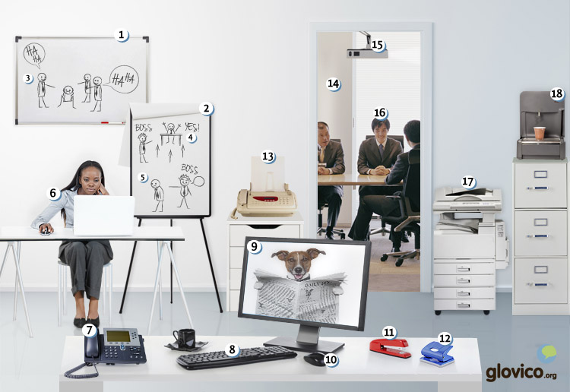

Talking

Job interview
After the raise you were negotiating for in the last lesson never materialized you decided to quit. And the interest in you is very high, so that you have a job interview straightaway.

Thinking
- Think about the important milestones in your career so far.
- Consider the appropriate way to conduct job interviews in the language that you are learning.

Talking
- Introduce yourself.
- Convince your interview partner that you are the best candidate for this job.

Optional
- Negotiate salary, bonusses and benefits (such as health-insurance, vacation days or pension).

- See more at: http://www.glovico.org/syllabus/General/lesson20/talking#sthash.xChre880.dpuf Story telling

Writing

Write a business letter
Your efforts have paid off and you got the job that you were hunting for. Your first task is to write a letter to several business partners of your new company to introduce yourself and ask for a meeting to renegotiate the terms on which your company and these others work at the moment.

Preparation
- Consider the write form and style to write business letters.
- Think about how to introduce nicely that you want to renegotiate terms.

Writing
- Write your letter.
- Make sure to hit the right professional tone to underline the urgency of the meeting without scaring your business partners.

Review
- Check your spelling and review your style.
- Once you are happy with the letter, send it to your teacher so he or she can review it.

Reading

Tenga su primera experiencia profesional en el extranjero
La empresa Auto le ofrece una oportunidad única: El Programa Ingeniería Internacional (PII). El programa le permite aumentar su cualificación profesional con proyectos nacionales e internacionales en la ingeniería de automóviles.
Ofrecemos
- Programa internacional de 3 años, con un plan de formación profesional y entre 3 o 4 proyectos para ampliar sus conocimientos prácticos. Primero una estadía de 12 a 18 meses en España y a continuación el desarrollo de dos proyectos en el extranjero, preferiblemente en una de nuestras fábricas en Portugal o Francia.
- Posibilidad de incorporación laboral en Auto al finalizar el programa (según vacantes disponible)
- Formación continua
- Retribución competitiva
Buscamos
- Recién graduado en Ingeniería superior
- Dominio del idioma portugués o francés
- Interés en el sector del automóvil
- Flexibilidad y creatividad
- Motivación por trabajar al extranjero
¡Aproveche el programa y aplique hoy!

Una carta de presentación
Empresa Auto
Av. Providencia 492
Madrid
Estimado Señor Peña:
Me encuentro muy entusiasmado con el Programa Ingeniería Internacional que su empresa ofrece.
Soy recién graduado de Ingeniería Superior de la Universidad Politécnica de Madrid. Me especialicé en la Ingeniería de Vehículos y de Fabricación durante mis estudios. Acabo de finalizar mi tesis junto con la empresa Seat. Pasé tres meses en su fábrica en Barcelona e hice un proyecto sobre el control de calidad. Esa primera experiencia profesional me permitió aumentar mis conocimientos prácticos y reforzaba mi fascinación con el sector del automóvil.
Durante mis estudios tuve la oportunidad de pasar 6 meses de intercambio en Paris, Francia. Hablo francés con fluidez y me encantaría pasar más tiempo en Francia.
Con mi experiencia en la Ingeniería de Vehículos y mi estadía en extranjero su programa me parece ideal para mí. Espero que me den la oportunidad de demostrarles mis cualidades en una entrevista personal.
Atentamente,
Juan Fernando López del Valle

Culture

Writing a Spanish business letter
Writing a business letters in Spanish follows basically the same pattern as business letters globally, yet there are a few nuances to keep in mind while writing such. Particularly important in adapting the format of yout business letters to Spanish conventions are four items:
- Normally the address of the company that you are writing to is placed on the upper left while your address is placed below your signature. Of course, in the address of the company be as a specific as possible. If you know the person who takes care of the application process, address him or her directly. If you only know the department, address that. Only as an option of last resort, address to the company in general.
- The date is placed below the address and normally aligned to the right. Also add the city from which you are writing here.
- For the openings you have a variety of options such as
  - Estimado Señor/ Estimada Señora
  - Apreciado Señor/ Apreciada Señora Señores
  - Muy Sr. mío / Muy Sra. mía
  - Distinguido Señor/ Distinguida Señora
- For the closings you have three basic items to choose from
  - Saludos cordiales
  - Atentamente le saluda
  - Atentamente
While there are still slight differences in formatting between Latin American countries you will be fine with the rules above in general. Below you find an example of a cover letter for an application in Spanish formatting.

Grammar

Further uses of the subjunctive

Express your emotions with the subjunctive
After expressing the subject’s emotions (e.g., joy, fear, hope, regret) about a topic the subjunctive is required.
Prefiero que vayan contigo. | I prefer that they go with you.
Se extrañan que no llamemos. | They are surprised that we don’t call.
A mi abuelo, le encanta que le llame cada día. | My grandfather loves that I call him every day.
The following verbs can all be used to express emotions about an event or an action and require the subjunctive, if the subject of the main clause (that expresses the emotion) differs from the subject of the subordinate clause (that is involved in the event or action).
aburrir | to bore
alegrar(se) | to be pleased
consolar | to comfort
divertir (ie) | to entertain
doler (ue) | to hurt
encantar | to love
esperar | to hope
extrañar(se) | to surprise
gustar | to like
interesar | to interest
lamentar | to regret
molestar | to disturb
preferir (ie) | to prefer
sorprender | to surprise
sentir (ie) | to regret
If the subject of the main and the subordinate clause is identical you use the infinitive. Contrast the following examples and note where the subject changes between main and subordinate clause and where it remains the same.
Quiero ir contigo. | I would like to go with you.
Quiero que vayan contigo. | I would like them to go with you.
Me encanta viajar. | I love travelling.
Me encanta que viajen. | I love that they travel.

Give your opinion with the subjunctive
If you give your opinion with verbs like parecer + adjective or use an impersonal statement like es importante, you need to use the subjunctive in the subordinate clause.
Me parece difícil que lo organices sólo. | It seems difficult for you to organize it by yourself.
Es mejor que lo hagamos juntos. | It is better if we do it together.
Es normal que el niño duerma mal. | It is normal that the child sleeps badly.
Typical adjectives and phrases that are used in combination with es or me parece express an opinion.
aconsejable | advisable
bueno | good
difícil | difficult
extraño | strange
fácil | easy
importante | important
imposible | impossible
justo | just, fair
una lástima | shame
lógico | logical
malo | bad
mejor | better
necesario | necessary
normal | normal
una pena | pity
urgente | urgent

More on the imperative
You have already seen the imperative for the second person singular (tú) in lesson 12. Apart from a few irregular verbs, you take the indicative present tense of the third person singular. For example, ¡Limpia la cocina! (Clean the kitchen!) or ¡Repara la bicicleta! (Repare the bike!).

Usted and ustedes imperative
Now that you know how to form the subjunctive you learn the third person singular and plural imperative. It is identical to the respective subjunctive form. You use it to order a person or a group of people that you usually address with the formal usted or ustedes.
¡Abra la puerta! | Open the door!
¡Vengan conmigo! | Come with me!

Vosotros/as imperative
The second person plural imperative is used to order a group of people that you are familiar with and typically address with vosotros/as. It is formed by replacing the verb ending -r by -d.
¡Habla + d! | Speak!
¡Bebe + d! | Drink!
¡Vivi + d! | Live!
The only exception to this rule, is for reflexive verbs. You leave out the -d in front of the reflexive pronoun.
¡Peinad el pelo al niño! | Brush the child’s hair!
¡Peinaos el pelo! | Brush your hair!

Nosotros/as imperative
You can also the imperative to order a group that you form part of. In that case you use the first person plural imperative. It is formed by first person plural subjunctive form of the verb.,
¡Hablemos con ellos! | Let’s talk to them!
¡Bebamos una cerveza! | Let’s drink a beer!

Vocabulary
Spanish | English
el teclado | keyboard
el monitor | monitor
el ratón | mouse
la engrapadora | stapler
la perforadora | punch
el fax | fax
la sala de conferencias | conference room
el proyector | projector
el gerente | manager
la impresora | printer
el anuncio | ad
la oficina | office
el aumento | raise
la entrevista | interview
el trabajo en equipo | team work
por ejemplo | for example
en otras palabras | in other words
lo que quiere decir es... | what I want to say is that...
contratar | to hire
jubilarse | to retire
despedir (ie) | to fire
las prácticas | internship
el currículum vitae (CV) | CV
la carta de presentación | cover letter
Estimado/a señor/a: | Dear Sir/Madam,
Atentamente, | Yours (sincerely/faithfully),
Cordialmente, | Sincerely,
aprovechar | to take advantage
aplicar | to apply
la experiencia | experience
profesional | professional
el proyecto | project
permitir | to allow
único/a | unique
la oportunidad | opportunity
el extranjero | foreigner, abroad
aumentar | to augment
la cualificación | qualification
internacional | international
la ingeniería | engineering
el automóvil | automobile
el programa | program
la formación | training
ampliar | to extend, to increase
el conocimiento | knowledge
práctico/a | practical
la estadía | stay
a continuación | next
el desarrollo | development
preferiblemente | preferably
la posibilidad | possibility
la incorporación | incorporation (start of work)
finalizar | to finish, to complete
continuo/a | continuous
la retribución | compensation
competitivo/a | competitive
recién | recently, newly
graduado/a | graduated
la ingeniería superior | Engineering (Masters level)
el dominio | command
el idioma | language
portugués | Portuguese
francés | Frenc
el interés | interest
la flexibilidad | flexibility
la creatividad | creativity
la motivación | motivation
entusiasmado/a | enthusiastic
especializarse | to specialize
la fabricación
el vehículo
la tesis | thesis
los estudios | studies
el control de calidad | quality control
reforzar | to reinforce
junto con | together with
demostrar | to show
con fluidez | fluently
la fascinación | fascination
aburrir | to bore
alegrar(se) | to be pleased
consolar | to comfort
divertir (ie) | to entertain
extrañar(se) | to surprise
lamentar | to regret
sentir (ie) | to regret
aconsejable | advisable
extraño | strange
importante | important
imposible | impossible
justo | just, fair
una lástima | shame
lógico | logical
una pena | pity
urgente | urgent

