Lesson 17

At the Doctor

Ir al médico

In this Spanish lesson you learn to
- Describe your state of health
- Talk about the parts of your body
- Ask for and respond to suggestions about plans
- Talk about what used to happen and what you used to do in the past
- Take shortcuts when communicating
Vocab Canvas

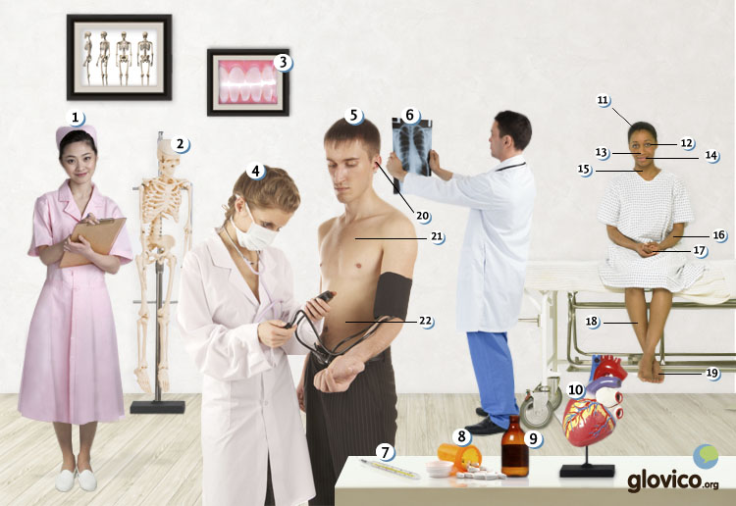

Talking

Annual Check-Up
You have to go for your annual check-up and your doctor asks you about your health.

Thinking
- What medical issues could you have while being abroad?
- Further consider what kind of treatments your prefer: do you rather trust traditional/ herbal treatments or modern/ pill-based medicine?

Talking
- Give your doctor an overview of your physcial status.
- Name particular issues/ body-parts that you have problems with.

Optional
- Discuss your preferences in terms of treatments.

Story telling
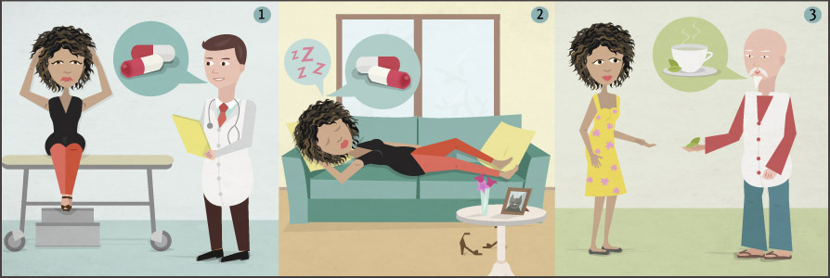

Writing

Write an email to your health insurance
You are travelling and recently began to feel very sick. You already went to the doctor and he recommended a rather uncovential therapy that will approximately last two weeks but is rather expensive. In order to be on the safe side, you decide to write your health insurance an email to see whether they will cover the therapy or if they have alternative recommendations.

Preparation
- Review how to write a professional email.
- Consider all the body aparts again that you know so far as well as sicknesses. Then decide for a few body parts that hurt and a sickness.

Writing
- Give a description of your sickness and describe the proposed therapy.
- Ask for coverage and alternate recommendations.

Reading

El frío
En invierno hacía mucho frío en Santiago de Chile. Llovía más de lo normal. Nico iba en bicicleta a su trabajo, casi una media hora por la mañana y por la noche. Después de mojarse mucho un día cuando volvía a casa, Nico se sentía enfermo. Le dolía la garganta y tenía dolor de cabeza. Después de algunos días decidió ir al médico.
Médico: Buenas tardes, señor Mercado. ¿Cómo se siente?
Nico: Me duele la cabeza y la garganta. Pienso que tengo fiebre. Además he dormido muy mal.
Médico: Ok. ¿Cuándo han empezado con los síntomas?
Nico: Hace dos o tres días.
Médico: Bueno. Voy a tomarle su temperatura. Me parece que es una infección de la garganta. ¿Ha pasado mucho tiempo fuera en el frío?
Nico: Sí. Tomaba la bicicleta cada día para ir al trabajo.
Médico: Usted tiene una temperatura de 39.5 grados. Es bastante elevada. Usted tiene una infección de la garganta. Voy a prescribirle un antibiótico. Va a mejorarse en dos días.
Nico: Gracias.
Médico: Aquí tiene una receta. Tiene que comprarlo a la farmacia y luego volver a quedarse en la cama. Se lo tiene que tomar dos veces cada día: por la mañana después de desayunar y por la noche antes de dormirse. ¡Y cuidado con el frío que hace!

Una urgencia
El jueves pasado practicamos baloncesto con unos amigos de la universidad como todos los jueves. Jugábamos cuando oí un grito. Mi amigo Jaime se cayó al suelo cuando intentó marcar una canasta. Fui a ver su pierna. Se podía ver que estaba muy mala y probablemente rota. Corrí para traer mi móvil. Marqué 911 y llamé una ambulancia. Jaime lloraba y gritaba mucho. ¡Qué dolor!
Después de hacer una radiografía, el médico decidió operarle a la pierna a Jaime. Ahora lleva una escayola y debe guardar cama durante seis semanas. Y después debe dejar de hacer deporte durante seis meses. ¡Qué mala suerte, le encantan los deportes!

- See more at: http://www.glovico.org/syllabus/Spanish/lesson17/content#sthash.qyQWtrJk.dpuf

Culture

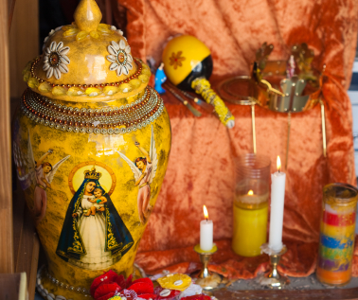

Santeria
In Latin America culture you will oftentimes find people drawing upon witches or saints to cure various illnesses (or before a first date as well as important business meetings). Most known for this tradition, also known as "Santeria" is the Dominican Republic but you will find it a lot throughout Middle America. Beliefs from various backgrounds blend in the Santeria traditions: native Indian heritage, Christian beliefs as well as rituals of African slaves that were brouight to the Caribeans.
The Dominican republic has a particularly colorful blend of traditions due to its strong African influence. Santeria, or white magic, as it is sometimes called, only does magic which doen not intent to harm others (other than its black magic counterpart). And oftentimes this magic summons saints whose pictures you might also find in European Christian monasteries. This fact being surprising in the beginning besomes very understandable once one considers that for several centuries European missionaries tried to impose their beliefs on the native Indian population as well as the black slaves.
In Cuba Santeria is closely related to traditional herbal medicine and the belief in the healing powers of nature. And the Cuban health system has a pretty good reputation.

Grammar

Express what used to happen: Imperfect
You already know that you can talk about events in the very recent past using the present perfect ("Hoy he ido al mercado hoy.") and that you express events that happened at the certain point in the more distant past using the preterit ("Ayer llegaron a las ocho.").
Now you learn to express situations that do not have a specific starting or ending point. For example, sentences like "I used to go to the gym regularly." or "Last week it was cold." require the imperfect.
Luckily there are only three irregular verbs in the imperfect, so there is a lot less to study than for the preterite.

Regular verbs in the imperfect

-ar verbs
 | hablar
yo | habl + aba
tú | habl + abas
él, ella, usted | habl + aba
nosotros/as | habl + ábamos
vosotros/as | habl + abais
ellos, ellas, ustedes | habl + aban
Take a look at some examples using the imperfect.
Estaba en Alemania algunas veces. | I was in Germany a few times.
Siempre me gustaban los Simpsons. | I always liked the Simpsons.

-er and -ir verbs
Verbs ending in -er and -ir take the same endings in the imperfect.
 | beber | vivir
yo | beb + ía | viv + ía
tú | beb + ías | viv + ías
él, ella, usted | beb + ía | viv + ía
nosotros/as | beb + íamos | viv + íamos
vosotros/as | beb + íais | viv + íais
ellos, ellas, ustedes | beb + ían | viv + ían
Take a look at some examples using the imperfect.
Ana vivía en España antes. | Anna lived in Spain before.
Hacía sol ayer. | It was sunny yesterday.

Irregular verbs in the imperfect
Only the verbs ser, irver are irregular in the Spanish imperfect.
 | ser | ir | ver
yo | era | iba | veía
tú | eras | ibas | veías
él, ella, usted | era | iba | veía
nosotros/as | éramos | íbamos | veíamos
vosotros/as | erais | ibais | veíais
ellos, ellas, ustedes | eran | iban | veían

Using the imperfect

Characteristics or states
Use the imperfect to describe the characteristics or states when the beginning or ending are not specified.
Mi abuela era inteligente. | My grandmother was intelligent.
Hacía mucho frío en Dinamarca. | It was very cold in Denmark.

Repeated or continuous actions
The imperfect is used to describe actions that repeatedly took place in the past without implying a beginning or ending.
Como niños jugábamos al fútbol. | As children we used to play football.
Comían en el restaurant chino cerca de su oficina. | They used to eat at the Chinese restaurant close to their office.

Actions or events that are in progress while something else takes place
Furthermore, you use the imperfect to describe an action or event that took place while something else happened.
Estaban en el jardín cuando llegaron sus hijos. | They were in the garden, when their children arrived.
Hablaba con mi hermana cuando el teléfono sonó. | I talked to my sister when the phone rang.

More on indirect object pronouns

Emphasis using indirect object pronouns
To emphasize an indirect object pronoun, you can reinforce by adding a mí/ti/... as follows.
me... a mí
te... a ti
le... a él, a ella, a usted;
nos... a vosotros/as
os... a nosotros/as
les... a ellos, a ellas, a ustedes

A mí, me gusta viajar. | I like traveling.
Le doy el libra a ella. | I will give her the book.
In addition to emphasizing the indirect object pronoun, you see that in the second example, the a ella helps to clarify who the le refers to.

Combinations of direct and indirect object pronouns
The indirect object pronoun always precedes the direct object pronoun, if both appear in the same sentence.
Te lo doy. | I give it to you.
Nos las compran esta semana. | They buy it for us this week
In case, direct and indirect object pronouns are used in the same sentence, the third person pronouns change as follows.
le/les + lo | se lo
le/les + la | se la
le/les + los | se los
le/les + las | se las
Some examples illustrate these changes.
¿Le has preguntado que va a hacer? | Sí, se lo he preguntado.
¿Le has comprado la mesa? | Sí, se la he comprado.

Vcabulary
Spanish | English
el/la enfermero/a | nurse
el/la médico/a | doctor
el paciente | patient
el hospital | hospital
el seguro | insurance
enfermo/a | ill
sano/a | healthy
los labios | lips
la oreja | ear
la boca | mouth
la nariz | nose
el ojo | eye
la cabeza | head
la lengua | tongue
la garganta | throat
el pecho | chest
el vientre | belly
el estómago | stomach
la espalda | back
el corazón | heart
el brazo | arm
la pierna | leg
el pie | foot
el cuello | neck
doler (ue) | to hurt
romperse (un hueso) | to break a bone
tener fiebre | to have a fever
tener dolor de cabeza | to have a headache
tener tos | to have a cough
tener resfriado | to have a cold
el dolor | pain
la enfermedad | illness
la inyección | shot
la vacuna | vaccine
la radiografía | X-ray
el síntoma | symptom
la urgencia | urgency
la ambulancia | ambulance
mejorarse | to get better
operar | to operate
recetar | to prescribe
guardar cama | to stay in bed
tomar la temperatura | to take the temperature
la pastilla | pill
la aspirina | aspirin
la medicina | medicine
el antibiótico | antibiotic
el calmante | tranquilizer
la receta | prescription
la escayola | plaster cast
casi | almost
fuera | out, outside
dejar de + infinitive | to stop + participle
elevado/a | high
gritar | to shout, to scream
el grito | scream, shout
llorar | to cry
marcar | to mark, to dial
marcar una canasta | to score (basketball)

