Lesson 16

Downtown - En el centro

In this lesson you learn to
- Discuss city life
- Give recommendations to others
- Express opinions with reasons

Vocab Canvas

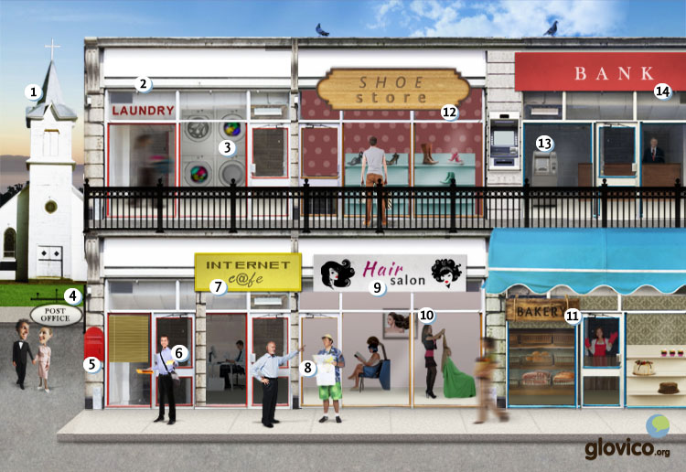

Talking

Walking versus driving
You are having a discussion with a friend on the advantages and disadvantages of pedestrian city centers versus cities that are easily accessible through cars. What do you think?

Thinking
- What is your opinion? Do you prefer city centers without cars or do you like the convenience of being able to reach by car.
- Think about good arguments.

Talking
- State your opinion and your arguments.
- Counter the arguments that your friend/ language teacher might have.

Optional
- Discuss the rhetoric habits of the culture of your teacher (would people easily state disagreement, how are arguments introduced,etc.).

Story telling
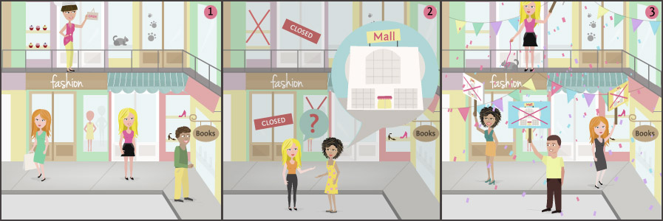

Writing

Write an email
The couchsurfer you visited in lesson 2 wants to visit you back. Yet, you are very busy at the moment with your language studies which means that you will accomodate her but won't be able to spend all the time with her. In order to get her prepared you write her an email explaining how to get from the train station to your place as well as a description of the city center so that he or she will able to get around there and has an impression of the various attractions and activties up front.

Preparation
- Review how to give advice.

Writing
- Give her a detail description on how to get to you from the train station.
- Recommend her a number of things to do around the city.

Review
- Check your spelling.
- Once you are happy with your email, send it to your teacher so he or she can review it.

Reading

¿Qué hiciste el sábado?
Pablo está un poco nervioso, ha intentado llamar a su hermana algunas veces este fin de semana. Pero ella nunca ha contestado.
Pablo: Hola María. ¿Qué pasa? ¿Qué hiciste ayer? Intenté llamarte tres veces.
María: Hola Pablo. No hay porque preocuparte. Ayer estuve en el centro de la ciudad todo el día. Hice las compras para la semana. Primero, fui a la panadería y compré pan y unos panecillos. Luego, fui a la carnecería para comprar jamón y salchichas. Después visité a mi amiga Carmen que trabaja en una zapatería. Carmen me mostró la tienda. A mediodía vinieron otras dos amigas. Nos probamos muchos zapatos. Después fui a la farmacia para comprar algunas cosas y luego fui a la joyería. Vi muchas cadenas para el cumpleaños de nuestra prima Valentina. Pero al final no pude decidirme. Voy a volver la semana que viene. ¿Quieres acompañarme?

El coche nuevo
Carlos y su mujer Susana quieren comprar un coche nuevo. Eligieron el nuevo coche hace dos meses, pero aún no han ahorrado suficiente dinero para comprarlo. Ayer Carlos fue al banco para informarse sobre préstamos. Conoció al empleado del banco hace un año en una fiesta de amigos y le parece posible obtener mejores condiciones de él.
Carlos: Susana, acabo de hablar con el empleado del banco. Nos ofreció un préstamo de 5000 euros con una tasa de interés de 4%. No me gustan los préstamos, pero solamente tenemos 10000 euros en las cuentas de ahorro y las tarjetas de crédito no son suficientes para el resto.
Susana: A mí no me gusta tampoco tener deudas. Pero queremos el coche ahora, tenemos buenos trabajos y no gastamos mucho. Vamos a amortizarlo pronto.
Carlos: Bueno. Entonces firmo el contrato y saco nuestros ahorros.
Con el préstamo de 5000 euros y sus ahorros Carlos y Susana pueden comprar el coche. Los padres de Carlos los conducen al centro de la ciudad donde está el vendedor de coches. Hay mucho tráfico en el camino y después de pasar los edificios de oficinas y una obra de un rascacielos, los cuatro se encuentran en un atasco.
Madre: ¿Por qué queréis un coche? No ahorráis ni tiempo ni dinero. Me encantaría pasar más tiempo al aire libre en bicicleta. Además hay una parada de autobús cerca de vuestra casa.

Culture

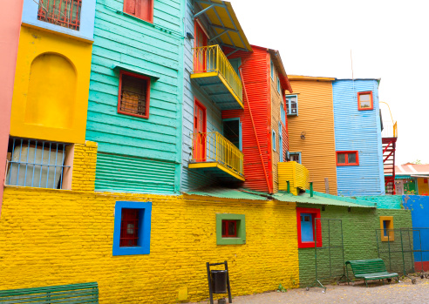

Buenos Aires
People sometimes consider Buenos Aires as a small piece of Europe down South in Latin America. The more poetic ones say it has the charme of on unshaved Italian lover. Definitly this beautiful city has a lot of European architecture with a variety of different flavors from amongst others Spain, Germany, Italy, and France. Sometimes one even has the feeling that Buenos Aires tries harder to be European than a European city ever would. While Buenos Aires is one of the largest cities in Latin America, it still is tremendously green and offers a huge number of parks. But also architecturally it has a lot to offer. Two highlights include the Recoleta Cemetery and the La Boca.

Recoleta Cemetery
This cemetery is one of Buenos Aires' architectural highlights and was designed in 1822 by the French architect Prosper Catelin. The area has been a religious site since the 1700s and was first home to a convent. In 1822 the convent's garden was made a public cemetery and was only redesigned once, in 1881. Guarding several of the city's most famous persons it is also one of its most visited touristic attractions. Probably the tomb that attracts most visitors is the one of "Evita", a former First Lady of Argentina. Yet, most of the tombs are worthwhile visiting due to their intricate designs - ranging from Art Deco to Neo Gothic.

La Boca
Looking for more "lively" areas you will feel well placed in one of the city's poorest barrios which is at the same time its most colorful one: La Boca. Close to Buenos Aires' old port, La Boca was first inhabited by Italian fishermen. The houses were predominantly built with wood and painted in bright colours. It is being told that the fishermen used the paint leftover from their boats for this. Unfortunatelly one street in particular, the "Caminito", has fallen prey to hoards of tourists and even bigger hoards of locals trying to make business. This goes back to the 1960s and the initiative of one of the city's most famous artists (Benito Quinquela Martín) who was originally from La Boca, who wanted to revive this poor area of Buenos Aires by enouraging street art. Together with some artist friends he secured several buildings that were about to be torn down in La Boca and moved them to the "Caminito". Through coloring them brightly he changed the neighboorhod and gave birth to the touristic attraction that you can see today.

Grammar

Discuss past events: preterit III

Irregular verbs in the preterit
In this section you will learn some further groups of irregular verbs in the preterit.

Verbs with -er/-ir ending, but without accent marks
Dar and ver both take the endings of regular -er/-ir verbs in the preterit, however without the accent marks on the first and third person singular.
<
 | dar | ver
yo | di | vi
tú | diste | viste
él, ella, usted | dio | vio
nosotros/as | dimos | vimos
vosotros/as | disteis | visteis
ellos, ellas, ustedes | dieron | vieron

Verbs that form the preterit with a stem-change to u
For the following verbs you need to remember the stem-change: poder -> pud, poner -> pus and saber -> sup.
 | poder -> pud | poner-> pus | saber -> sup
yo | pude | puse | supe
tú | pudiste | pusiste | supiste
él, ella, usted | pudo | puso | supo
nosotros/as | pudimos | pusimos | supimos
vosotros/as | pudisteis | pusisteis | supisteis
ellos, ellas, ustedes | pudieron | pusieron | supieron
Note that the endings of the first and third person singular are irregular. Furthermore, the emphasis of these forms is on the stem of the verb (and not the ending as for regular preterit forms).

Verbs that form the preterit with a stem-change to i
Similar to the previous group of verbs, some verbs have a stem-change in the preterit that involves an i: decir -> dij, hacer -> hic, querer -> quis and venir -> vin.
 | decir -> dij | hacer -> hic | querer -> quis | venir -> vin
yo | dije | hice | quise | vine
tú | dijiste | hiciste | quisiste | viniste
él, ella, usted | dijo | hizo | quiso | vino
nosotros/as | dijimos | hicimos | quisimos | vinimos
vosotros/as | dijisteis | hicisteis | quisisteis | vinisteis
ellos, ellas, ustedes | dijeron | hicieron | quisieron | vinieron
Note that these group of verbs shares the endings with the previous group. Only for decir the third person plural has an irregular ending.
La semana pasada me dijeron otra razón. | Last week they told me another reason.
Due to phonetic reasons the third person singular of hacer is formed with z instead of c.
Ayer hizo mucho calor. | Yesterday it was very hot.

Changes in meaning between present tense and preterit
There are a few Spanish verbs that have a different connotation in the preterit than in the present tense.
Verb | Present tense | Preterit
poder | to be able to | to manage to do
no poder | to not be able to | to fail to do
querer | to want | to try
no querer | to not want | to refuse
conocer | to know someone/a place | to meet someone
saber | to know a fact | to find out, to learn

Conocí a Pedro el mes pasado. | I met Pedro last month.
No pudimos llegar a la cumbre. | We failed to reach the summit.
¿Cuándo supiste su occupación? | When did you find out about his occupation?

Adverbs expressing agreement and negation
You already know siempre, también and ya to express agreement and nunca, nadie and nada to express negation. Now you will learn some further expressions and review how to use the negative expression.
Agreement |  | Negation
siempre | always | jamás, nunca | never
o...o | either...or | ni...ni | neither...nor
también | too, also | tampoco | not either, neither
ya | already | ya no | no longer, not anymore
aún | still | aún no | not yet
You have already seen that some Spanish sentences require a double negation (they remain negative), for example: "No he nunca visitado a Colombia." Similarly, the negative expressions jamás, ni...ni and tampoco that you learnt today require a no in front of the verb, if they follow the verbs. In case the negative expression stands in front of the verb, you do not require a no in the sentence. Aún no and ya noalready include a no in the expression, they do not need an additional no.
Jamás he visto la película. | No he visto la película jamás.
Ni mi madre ni mi padre saben bailar. | No saben bailar ni mi madre ni mi padre.
Tampoco conozco a Ana. | No conozco a Ana tampoco.

Vcabulary
Spanish | English
la panadería | bakery
la carnicería | butcher
la papelería | stationery
la farmacia | pharmacy
la librería | bookstore
la zapatería | shoe shop
la joyería | jeweler’s shop
la lavandería | laundry
la florería | flower shop
el peluquero | hairdresser
el/la empleado/a | employee
la biblioteca | library
el mercado | market
la calle principal | main street
el centro comercial | mall
el banco | bank
el cajero automático | ATM, cash dispenser
la avenida | avenue
la esquina | corner
el peatón | pedestrian
la parada de autobuses | bus stop
la acera | sidewalk
el edificio | building
el hospital | hospital
el ayuntamiento | town hall
la iglesia | church
construir | to build
el rascacielos | skycraper
el bloque de pisos | high-rise building
la fábrica | factory
el estacionamiento | parking
el edificio de oficinas | office building
el puente | bridge
la autopista | freeway
la obra | building site
la multa | fine (e.g., traffic)
la desviación | diversion, detour
la salida | exit
tirar | to pull
empujar | to push
el tráfico | traffic
el atasco | traffic jam
el ruido | noise
la tarjeta de débito | debit card
gastar | to spend
la cuenta corriente | checking account
la cuenta de ahorro | saving account
el préstamo | loan
los intereses | interest
la tasa de interés | interest rate
la moneda | currency
ahorrar | to save
la deuda | debt
el cheque | check
el/la cajero/a | cashier, teller
sacar dinero | to take out money
cambiar | to change
devolver (ue) | to give back, to return
contestar | to answer
No hay porque preocuparte. | Don’t worry.
elegir | to choose
firmar | to sign
el contrato | contract
amortizar | to repay (loan)
obtener | to get, to obtain
ofrecer | to offer
suficiente | enough

