Lesson 14

Sports-Los deportes

In this lesson you learn to
- Talk about different sports
- Report past events and activities
- Express your ability/knowledge of activities
- Use typical exclamations
- Give and receive apologies

Vocab Canvas

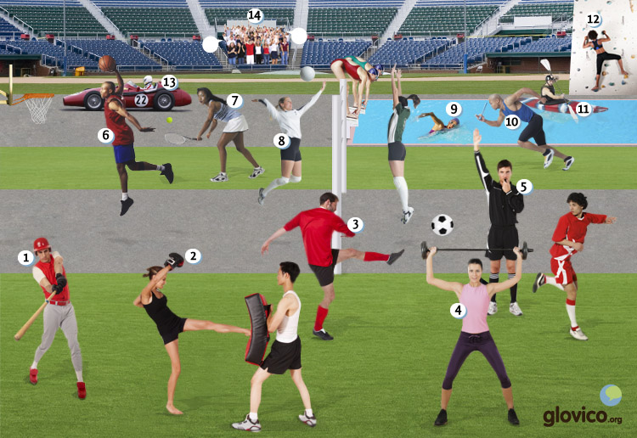

Talking

The week after
It's the week after you were on the road with your friends. You are on the phone with one of your friends who hasn't been with you and who is a little mad because you forgot to invite him (about which you are very embarassed).

Thinking
- Think about a good excuse.
- Consider the appropriate way to tell him about the weekend.

Talking
- Make your apologies to your friend.
- Tell her/ him about the weekend but play things down a bit (also remember to use the past).

Optional
- Plan some sports event together with your friend.

Story telling
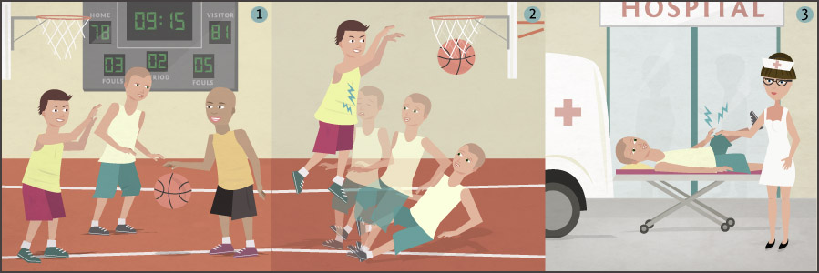

Writing

Blogging about your weekend trip
After having had a thrilling weekend with your friends you decide to blog about it.

Preparation
- Consider the grammatical structures of how to report something in the past.
- Write in a funny style to entertain your readers.

Writing
- Write a blog article about the weekend trip and report the main events.
- Add some funny details to entertain your readers.

Review
- Check your spelling and the grammar.
- Check whether the blog article is entertaining.
- Once you are happy with your blog article, send it to your teacher so he or she can review it.

Reading

La semifinal

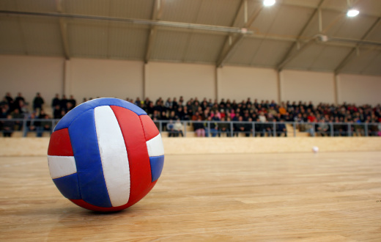
Hoy es un día muy importante para Juan y su hermana Mariana: es la semifinal del campeonato mundial de vólibol. Son aficionados del equipo nacional de Cuba porque su abuelo es de Cuba y les encanta el país. Compraron las entradas hace tres meses y ya están un poco nerviosos antes del partido. Cuba tiene que jugar contra Italia que ganó el campeonato el año pasado con 5-2 contra Brasil.
Mariana: Todavía tenemos tres horas, pero ¿qué te parece si vamos al estadio ahora?
Juan: Me parece una buena idea. Siempre lo pasamos muy bien con los aficionados del equipo cubano.
Mariana: ¡Vamos!
Llegan al estadio media hora después.
Juan: Mariana, no encuentro las entradas. ¿Las tienes en tu bolsa?
Mariana: Yo no. Me has dicho que tú las tienes. ¿Tú no las tienes?
Juan: ¡Caramba! Todavía están encima de la mesa en la cocina. Siento haber olvidado traerlas.
Mariana: No pasa nada. El partido empieza en dos horas y media. Tienes mucho tiempo para volver a casa y traerlas.
Juan: Vale. ¿Y tú, qué vas a hacer?
Mariana: Voy a llamar a Pedro, él va a venir también para el partido. Tomamos una cerveza.
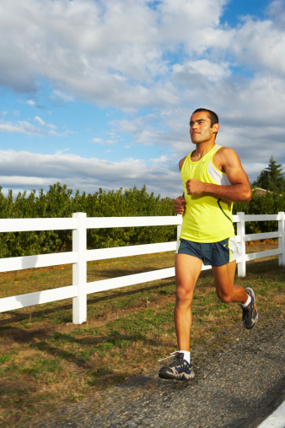

Fernando corre
Ayer pasé un día muy deportivo. Nadé en la piscina por la mañana y corrí una hora por la tarde. Corro desde hace seis meses y me gusta mucho. Estoy preparando mi primer maratón. Voy a hacerlo en dos semanas. Hace una semana dos de mis amigos decidieron acompañarme. Pienso que ya han comprado sus entradas. ¡Ojalá!
Anoche compré comida china en mi restaurante favorito y después miré la televisión. Mi equipo favorito perdió contra el campeón de la temporada pasada. El árbitro se equivocó y no notó la falta antes del último gol. ¿Qué lástima!

- See more at: http://www.glovico.org/syllabus/Spanish/lesson14/content#sthash.NfrFdh07.dpuf

Culture

Tarahumara
Hidden in Copper Canyon in the Mexican Sierra Madre lives an indigenous tribe, famous for its running skills. Known as the Tarahumara Indians, or Rarámuri, as they call themselves, they are one of the largest indigenous groups in the whole Northern Americas. And living in a hostile and inaccessible part of the Sierra Madre also one of the most reclusive indigenous groups without any modern technology or even electricity.
Yet, as their self-given name already states ('Rarámuri' means 'foot-runner' or 'one who walks well'), they are keen runners. Something which is not surprising given that the typical Tarahumaran prefers to live reclusive and at far distances from one another and given the fact that there are no cars, well not even roads in Copper Canyon. Still, what is rather astonishing is the fact that they are not only keen runners but outstanding runners. So outstanding that they are able to outrun US American ultramarathon professionals while having a smoke during the run and running barefoot or in sandals.
And while typically "innovation" is brought into indigenous communities in this case it seems like things are vice versa and a barefoot running trend is now sweeping throught the European and North-American runners' community. And this trend was to a large extent inspired by the book "Born to Run" by Christopher McDougall published in 2009 featuring - who would have guessed - the Tarahumara.
So it seems like one can learn - or relearn - a lot from indigenous communities around the world. Even for such modern things as going for a run.

Grammar

Discuss past events: preterit
To talk about events and activities that took place in the past, you use the preterit in Spanish. In this lesson you will learn how to form the regular forms of the preterit, in the next two lessons you will learn about the irregular verbs in the preterit. In lesson 17 you will be introduced to another past tense, the imperfect.

Regular -ar verbs in the preterit
The regular -ar verbs have the following endings in the preterit. Note that the emphasis is always on the last syllable.
hablar
yo | habl + é
tú | habl + aste
él, ella, usted | habl + ó
nosostros/as | habl + amos
vosotros/as | habl + asteis
ellos, ellas, ustedes | habl + aron

Regular -er and -ir verbs in the preterit
The regular -er and -ir verbs share the same endings in the preterit. Again the emphasis in on the last syllable.
beber
yo | beb + í
tú | beb + iste
él, ella, usted | beb + ió
nosostros/as | beb + imos
vosotros/as | beb + isteis
ellos, ellas, ustedes | beb + ieron

vivir
yo | viv + í
tú | viv + iste
él, ella, usted | viv + ió
nosostros/as | viv + imos
vosotros/as | viv + isteis
ellos, ellas, ustedes | viv + ieron

When to use the preterit
In general you use the preterit to talk about events that took place at certain point in the past and that have already terminated. We will contrast its use to the present perfect, which is used to talk about activities that took place in the very recent past.

Using the preterit
Trabajé en la tienda ayer. | I worked in the shop yesterday.
La semana pasada comieron en el restaurant de Pablo. | Last week they ate in Pablo’s restaurant.
Vivimos en España el año pasado. | Last year we lived in Spain.
Note that the preterit for nosotros is the same as the present tense forms for verbs ending in -ar and -ir.

Using the preterit or the present perfect
There are some time indicators that require the use of the preterit or the present perfect.
present perfect | English | preterit | English
hoy | today | ayer | yesterday
esta mañana/tarde | this morning/afternoon | ayer por la mañana/tarde | yesterday morning/afternoon
esta noche | tonight | anoche | yesterday evening
esta semana | this week | la semana pasada | last week
alguna vez | sometime | el otro día | the other day
nunca | never | en enero/febrero... | in January/February...
ya | ever, already | el lunes | on Monday
In many parts of Latin America and in some areas in Spain, the preterit is used nearly exclusively (instead of the present perfect) in the oral language.

Excuses: sentir + haber + participle
To say that you are sorry for something you done (or not done), the following expression is useful.
sentir | haber | participle

Siento haber olvidado tus zapatos. | I’m sorry for forgetting your shoes.
Sentimos haber llegado tarde para tu fiesta. | We are sorry that we arrived late for your party.

Expressions relating to time: hace and desde hace

Express "ago" or duration: hace
Hace and a time expression can be used both to express a duration of time or to express how long ago something happened.

Hace for a duration
To express that an action has been taking place over a period of time, you use the following construction.
hace | time expression | que | verb in present tense

Hace dos meses que vivo en Santiago. | I have been living in Santiago for a month.
Hace dos años que estudiamos español. | We have studied Spanish for two years.
To ask how long somebody has been doing something, use the following construction.
¿Cuánto (tiempo) | hace | que | verb in present tense?

¿Cuánto tiempo hace que vives aquí? | How long have you been living here?
¿Cuánto tiempo hace que juegan al fútbol? | How long have they been playing football?

Hace for "ago"
If you want to express that something happened a certain time ago, you use a similar constructions, but the verb is in the preterit.
hace | time expression | que | verb in preterit
¿Cuánto (tiempo) | hace | que | verb in present tense?

Hace dos meses que visité a mis padres. | Two months ago I visited my parents.
¿Cuánto tiempo hace que llamaste a Paula? | How long ago did you call Paula?

Express since + time: desde hace + present/present perfect
Another way to express a duration of time, is using the following construction with desde hace.
verb in the present/present perfect | desde hace | time expression

Esperamos el tren desde hace media hora. | We have been waiting for the train for half an hour.
He vivido en Chile desde hace cuatro meses. | I have lived in Chile for four months.

- See more at: http://www.glovico.org/syllabus/Spanish/lesson14/grammar#sthash.jnLiuvjy.dpuf

Vcabulary
Spanish | English
el deportista | athlet
el campeón | champion
el equipo | team
la temporada | season
el atletismo | athletics
el baloncesto | basketball
el vólibol | volleyball
el tenis | tennis
la gimnasia | gymnastics
la meta | goal
ganar | to win
perder (ie) | to loose
hacer ejercicio | to exercise
el béisbol | baseball
el boxeo | boxing
la halterofilia | weight lifting
el árbitro | referee
el kayakismo | kayaking
la escalada | climbing
escalar | to climb
la carrera de coches | car race
el público | audience
alguna vez | sometime
ayer | yesterday
anoche | last night
nunca | never
el otro día | the other day
la semana pasada | last week
ayer por la mañana | yesterday morning
ayer por la tarde | yesterday afternoon
siento haber + participle | I’m sorry for having ...
la entrada | ticket
olvidar | forget
¡Qué lastima! | What a pity!
¡Vamos! | Let’s go.
¡Caramba! | Oh! (positive or negative)
Por Dios. | For heaven’s sake.
¡Ojo! | Watch out!
¡Ojalá! | Hopefully!
la final | final
la semifinal | semifinal
el/la aficionado/a | fan
nacional | national
nervioso/a | nervous
el estadio | stadium
cubano/a | Cuban
chino/a | Chinese
No pasa nada. | It doesn’t matter.
el maratón | marathon
la falta | foul
notar | to note
último/a | last
deportivo/a | sporty
- See more at: http://www.glovico.org/syllabus/Spanish/lesson14/vocapp#sthash.LX8w7xNJ.dpuf

