Lesson 13

Outdoors - Al aire libre

In this lesson you learn to
- Talk about outdoor activities that you like to do in your free time
- Make plans to do something
- Talk about the weather
- Ask for, offer and accept/refuse help
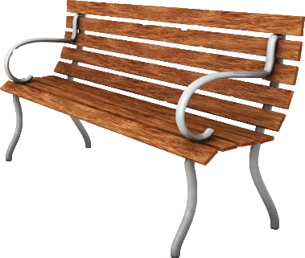

Vocab Canvas

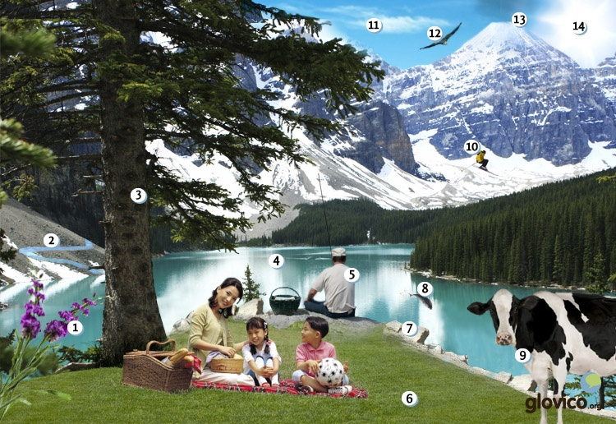

Talking

A weekend in the countryside
You and some friends plan a trip for the weekend. You discuss ideas of what to do and who does what.

Thinking
- Think about ideas of what one could do for a weekend in the country whose language you are learning.
- Consider the right words to express as well as disagreement.

Talking
- Propose your ideas and discuss them with your friend, the language teacher.
- He /she offers to help with organizing the trip but you decline.

Optional
- Discuss different options for good and bad weather.

Story telling
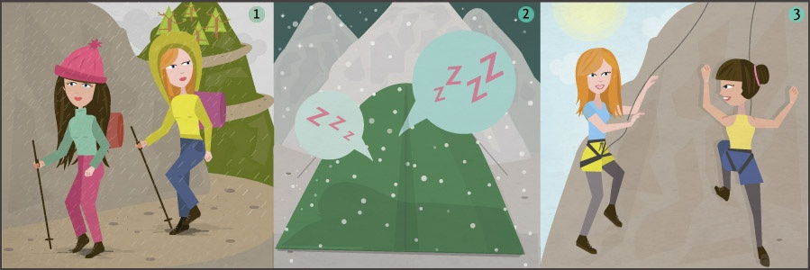

Writing

Organizing your weekend trip
After having discussed the main points regarding your weekend trip with your friends you decide to write them an email with a summary of the logistics so that everybody knows when to be where and what is planned for the weekend.

Preparation
- Consider the grammatical structures of how to plan something.
- Write in a motivational style to get your friends even more excited for the trip.

Writing
- Write an email with the main things to know about the weekend trip.
- Add some fun stuff to amuse your friends and make the email less "stiff".

Review
- Check your spelling and the grammar.
- Check whether the email is fun to read.
- Once you are happy with your email, send it to your teacher so he or she can review it.

Reading

Este año Diego quiere pasar sus vacaciones de verano en el campo. Le encanta pescar y hacer ciclismo. Le importa viajar con amigos, por eso pregunta a dos compañeros del trabajo si quieren acompañarlo. Mario se interesa también por el ciclismo y le dice que sí. Nico, el otro compañero, no quiere viajar con ellos, le molesta pasar demasiado tiempo al aire libre. Prefiere visitar conciertos y teatros en la ciudad.
Mario: ¿Qué te parece si viajamos a Pucón? Allí hay muchas montañas para hacer ciclismo.
Diego: ¿Podemos alquilar bicicletas allí?
Mario: Sí. Conozco un hostal que las alquila.
Diego: ¿Te gustaría mirar unos hostales en internet ahora? Me parece importante hacer una reservación pronto. En el verano hay muchísima gente que viaja a Pucón.
Mario: Es verdad. Te doy mi portátil. Voy a buscar el nombre del hostal que alquila las bicicletas.
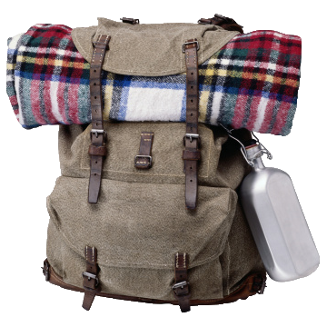

En la montaña
El día antes de salir de vacaciones Diego y Mario están preparando su equipaje.
Mario: ¿Tenemos todo?
Diego: Solamente nos faltan gafas de sol y protector solar. En la montaña el sol es muy fuerte.
Mario: Voy a comprarlos. ¿Me das la llave del coche? Voy a poner las mochilas dentro. Acabo de hacerlas.
Diego: Claro. Aquí la tienes. Acabo de ver el pronóstico para mañana. Va a hacer menos calor que hoy, más viento y quizás nieve.
Mario: Voy a volver a mirarlo más tarde. Me importa tener mucha información sobre las condiciones en la cumbre antes de subir. En media hora vuelvo con las compras.
Diego: ¿Puedo ayudarte con las mochilas?
Mario: No es necesario. Ya están abajo en el garaje.

Culture

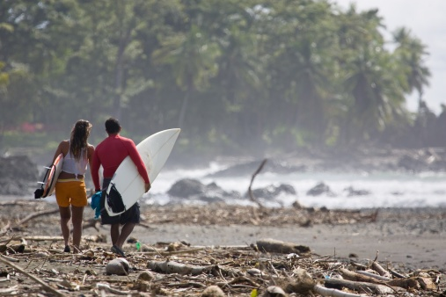

Las Olas
In case you are still looking for a reason to go and visit Costa Rica, consider its unique surfing culture. It has amazing beaches, great weather and awesome waves. And it is this combination that has made Costa Rica renowned amongst surfers globally for a few years now. Yet, it is not only that: also the people in the country are very welcoming towards visitors and will make you feel at home straight away.
While the country has a lot to offer, ranging from volcanoes and forests to tremendously rich wildlife, in recent years it is more and more the surfing that attracts young travellers to come to this Middle-American country. Particularly after it hosted the world surfing championship in 2009. As the first country ever in Central America!
It is most of all the beaches Jaco and Playa Hermosa that attract the global surf community. They are along the Pacific coastline and close to the country's capital, San José. And most importantly, they have outstanding and reliable waves. Which is probably why you can see a global surf event every other year in Costa Rica now.

Grammar

To or for whom?: indirect objects
The indirect object answers to whom or for whom. For example, in the sentence "I give a book to my sister.", you can ask "To whom do I give a book?". So "my sister" is the indirect object. Remember that "a book" is the direct object, which you studied previously.
Take "Ana buys a present for her mother." as another example. You can ask "For whom does Ana buy a present?". So "her mother" is the indirect object and "a present" is the direct object.

Indirect object pronouns
Similar to the direct object pronouns that replace direct objects there are indirect object pronouns. Note that they only differ from the direct object pronouns for the third person singular and plural.
me | me
te | you
le | him, her
nos | us
os | you
les | them, you

Use of indirect object pronouns: decir and dar
Decir (to say) and dar (to give) are two verbs that are often used with indirect objects. You already know how to conjugate decir, but dar has an irregularity in the first person singular: yo doy.
Voy a dar un libro a mi abuela. | Le voy a dar un libro. | I will give her a book.
¿Has dicho algo a mi padre?. | ¿Le has dicho algo? | Have you said anything to him?
Note that indirect object pronouns usually precede the conjugated form of the verb. In negative sentences the direct object pronoun is placed between the no and the conjugated form of the verb.
No nos dan mucho dinero. | They don’t give us a lot of money.
For verb constructions that use an infinitive, the indirect object pronouns can either precede the conjugated verb or be attached to the infinitive.
Mi hijo me quiere comprar un coche. | My son wants to buy me a car.
Mi hijo quiere comprarme un coche. | My son wants to buy me a car.

Use of indirect object pronouns: gustar, encantar and similar verbs
You already know how to use gustar to say you like doing something or like something and you can ask others about their likes. In fact, you have been using the indirect object pronouns in these constructions. Now that you know the indirect object pronouns, you can use gustar for all persons. Unlike the English construction "I like ...", me gusta is literally translated as "...pleases me", which explains why you use indirect object pronouns.
gustar (to like)
me gusta(n) | I like (...pleases me)
te gusta(n) | you like (...pleases you)
le gusta(n) | he, she likes (...pleases him, her)
nos gusta(n) | we like (...pleases us)
os gusta(n) | you like (...pleases you)
les gusta(n) | they like (...pleases them, you)
Take a look at some example phrases to see how to use gustar.
Nos gustan las peliculas. | We like films.
Les gusta la música. | They like music.
No le gusta trabajar. | He (or she or formal you) does not like working.
Note that you only use the third person singular and plural of gustar, because you want to indicate that something "is pleasing."
There are a number of verbs that are used similarly to gustar, with indirect objects pronouns and the third person singular and plural verb forms. Some of these follow.
encantar | to love, to delight
fascinar | to fascinate
interesar | to interest
importar | to matter
faltar | to lack
molestar | to bother
sorprender | to surprise
parecer | to seem
Note that parecer is usually followed by an adjective (and not a noun or a verb in the infinitive like gustar).
Este restaurante me parece caro. | This restaurant seem expensive to me.
Me parece interesante viajar mucho. | It seems interesting (to me) to travel a lot.

Express repetition, termination or previous events

Express repetition: volver a + infinitive
With volver a + infinitive you express that a repetition of an action that already took place in the past.
Vuelvo a estudiar. | I return to studying.
Se ha vuelto a hablar con su madre. | He started talking to his mother again.

Express termination: acabar de + infinitive
With acabar de + infinitive you express that something just happened.
Acabamos de llegar. | We just arrived.
Acabo de levantarme. | I just got up.

Express that something took place previously: antes de + infinitive
With antes de + infinitive you can talk about things that happened before the event that you are currently describing. For example, "Before going to the cinema, we had dinner."
La llamo antes de llegar. | I call her before arriving.
Antes de salir voy a cenar. | I will have dinner before going out.

- See more at: http://www.glovico.org/syllabus/Spanish/lesson13/grammar#sthash.ADWgVsSU.dpuf

Vcabulary
Spanish | English
¿Qué te parece si...? | What do you think about...?
el tiempo | weather
la lluvia | rain
la nube | cloud
el viento | wind
el aire | air
la niebla | fog
la nieve | snow
el sol | sun
el trueno | thunder
el rayo | lightning
nublado/a | cloudy
despejado/a | clear
soleado/a | sunny
el pronóstico | forecast
hace calor | it is hot
hace frío | it is cold
fresco/a | cold
llover (ue) | to rain
nevar (ie) | to snow
la flor | flower
la hoja | leaf
el río | river
el lago | lake
el arroyo | stream
la orilla | shore
la montaña | mountain
subir | to go up, to climb
la cumbre | summit
el alud | avalanche
el cielo | sky
esquiar | to ski
el valle | valley
acompañar | to go with, to accompany
el campo | countryside
pescar | to fish
el pez | fish
la vaca | cow
la gallina | chicken
el cerdo | pig
el ave | bird
el pasto | grass
hacer senderismo | hiking
el hielo | ice (water)
hacer un picnic | to have a picnic
el protector solar | sun cream
hacer ciclismo | to bike
el sombrero | hat
encantar | to love, to delight
interesar | to interest
importar | to matter
faltar | to lack
molestar | to disturb
sorprender | to surprise
parecer | to seem
volver a + infinite | to get back to, to return to
acabar de + infinitive | just + participle
antes de + infinitive | before + participle
la mochila | backpack
quizás | maybe
fuerte | strong
necesario | necessary
ayudar | to help
la condición | condition
abajo | down, below
arriba | up

