Lesson 12

In the Kitchen En la cocina

In this lesson you learn to
- Discuss cooking and recipes
- Understand and talk about measurements
- Describe in which manner you are doing things
- Learn the numbers from 100 - 1000

Vocab Canvas
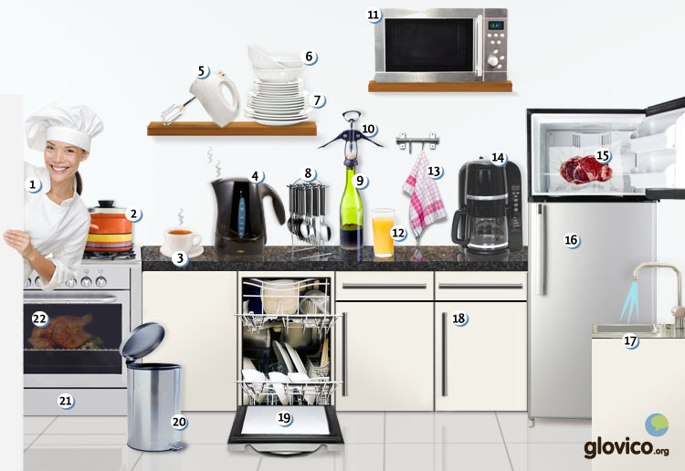

Talking

Talk about a recipe of your grandma
After the dinner of the previous lesson you and your friends have a conversation about your favorite dishes. You remember that one place where you always went with your parents which served a dish which you liked incredibly back then.

Thinking
- Think about the dish that you liked.
- Also think about how it was prepared.

Talking
- Share the story of your favorite dish with your friends (make sure to use the past).
- Also tell them about the way in which it was prepared.

Optional
- Describe the kitchen of the place in which you grew up (again of course, use the past).

Story telling
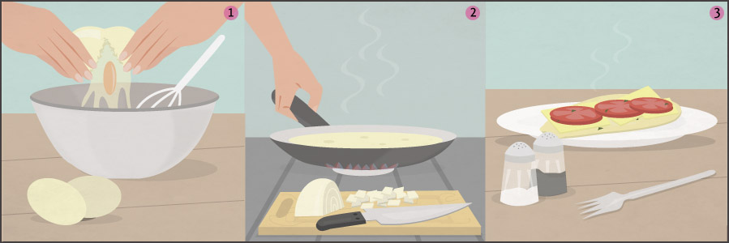

Writing

Translate your favorite recipe
The Palulauloaians have left their isolation and become amazingly fond of good food from around the world. Therefore they are now collecting recipes from around the globe and ask you to translate your favorite one.

Preparation
- Consider your favorite dish and find its recipe.
- Find out about measurements in the language that you are translating to (is it cups or ml, cm or inch, etc.).

Writing
- Translate your recipe.
- Give some hints for how one can the recipe even further.

Review
- Check your spelling.
- Check whether you applied a broad variety of the grammatical structures you learnt so far and included usage of as many kitchen items as possible.
- Once you are happy with your recipe, send it to your teacher so he or she can review it

Reading

Una barbacoa

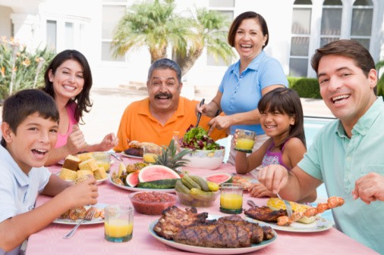
Todos los domingos la familia Peña hace una barbacoa en la casa de los abuelos de la familia. Viven fuera del centro de Santiago de Chile. Los padres normalmente traen una ensalada y las bebidas y los abuelos preparan la barbacoa, pasta y el postre. Los niños vienen con mucha alegría porque sus abuelos siempre tienen muchas golosinas en casa.
Abuela: Lo siento. Nuestra cafetera está rota, no puedo preparar café.
Madre: No pasa nada. Voy a preparar unos expresos. Tengo una máquina de mi hermano.
Abuela: Gracias, tomo un expreso. Pero tienes que usarla con cuidada, ya está muy antigua.
Padre: Tomo un expreso también. ¿Puedes traer una botella de vino tinto y el sacacorchos?
Madre: Claro. ¿Quién más quiere un expreso?
Abuelo: No gracias.
Abuela: ¿Saben cuánto cuesta una cafetera nueva?
Padre: He visto una por 30,000 pesos, pero si quieren una con muchas funciones puede ser unos 50,000 pesos.
Abuela: Es muchísimo. ¡Qué suerte que casi es Navidad!
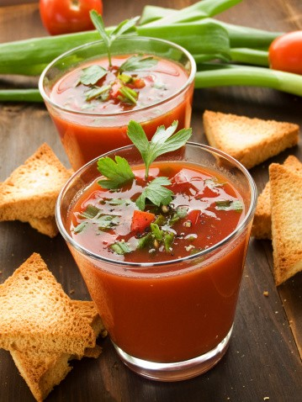

Gazpacho andaluz
Hay muchas recetas diferentes del gazpacho andaluz. Algunas incluyen pan, otros no quitan la piel de los tomates. Algunos incluyen ingredientes más exóticos como manzanas. Hoy vamos a ver un típico gazpacho andaluz, con tomate, pepino, pimiento y ajo.

Ingredientes
- 2 latas a 800g de tomates
- 1 pimiento rojo
- 1 cebolla
- 1 pepino pequeño
- 4 dientes de ajo
- 1 panecillo
- 1 cuchara de pimentón
- Vinagre
- Sal
- Aceite de oliva
- Una pizca de azúcar
- Una taza de agua fría

Preparación
Primero: Pon el panecillo en un cuenco. Cubrelo con agua.
Segundo: Lava, pela y trocea el pepino y el pimiento.
Tercero: Trocea el ajo y la cebolla.
Cuarto: Pon las verduras en un cuenco, añade una cuchara de vinagre, dos cucharas de aceite y un poco de sal. Mezcla bien y dejalo (mínimo dos horas).
Quinto: Quita la piel de los tomates y añadelas a la mezcla de verduras. También añade el panecillo.
Sexto: Toma una batidora para hacer una crema de las verduras y del panecillo.
Séptimo: Añade el agua de los tomates, el pimentón, la pizca de azúcar y agua frío (a gusto). Pon el gazpacho en el frigorífico.

Servir
Para servir el gazpacho, trocea tomates frescos, pepino, pimiento y cebolla. Las personas pueden añadir las verduras frescas a la sopa a su gusto. ¡Disfrute!

Culture

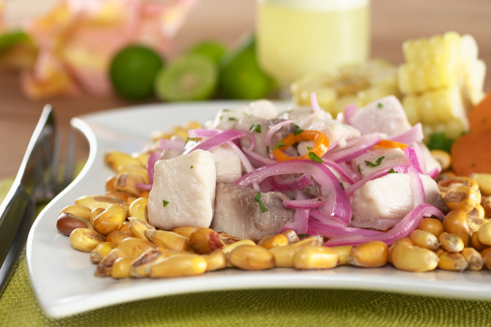

Ceviche
One of the strong points of Latin cuisine - apart from being delicious of course - is that sometimes its dishes also are very simple to prepare. While drawing on a lot of fresh stuff and very little processed food, Latin American cooking also has a healthy touch. One famous dish which is enjoyed in particular in the coastal regions of Nothern South America is Ceviche.
The basic idea behind a Ceviche is to take fresh fish and instead of cooking it, putting it into fresh lemon juice. In that way it is marinated and keeps its freshness. Obviously, as the fish is not cooked, only fresh fish is to be used in order to prevent food poisoning. While not being fully confirmed most sources agree that Ceviche is of Peruvian origin (and also most present there, particularly in coastal Lima).
Throughout Latin America various versions of the Ceviche exist. The classical Peruvian version has chunks of raw fish which are put into limo juice and has some chopped onions, chilis and spices added. Sometimes it is served with the marinate (called leche de tigre). Ecuador on the other hand uses shrimps instead of fish and adds some tomatoes whereas Chile uses fish again but adds garlic, mint and cilantro. Central America uses a broad variety of seafood in Ceviche and is sometimes served with crackers or tostadas. Once in a while one can even find it with Ketchup or Tabasco.
While a good ceviche is a great delight and in addition easy to prepare, when dining out always make sure that the fish that's used is fresh!

Grammar

Adverbs
Adverbs describe or modify verbs, adjectives, sentences or other adverbs. For example,
I walk slowly. Slowly describes the verb walk in more detail.
I am very sad. Very describes the adjective sad in more detail.
There are three main groups of adverbs in Spanish: simple adverbs, adverbs formed by adding -mente to adjectives and adverbs formed by using con + noun. You already know many simple adverbs: for example muy, demasiado, pronto, nunca, mal, siempre, poco.

Adverbs ending in -mente
Many Spanish adverbs are formed by adding -mente (corresponding to the English -ly) to the feminine singular form of adjectives that end in -o and in -a.
rápido | rápidamente
atento | atentamente
For adjectives that only have one form, you add -mente to that form.
alegre | alegremente
fácil | fácilmente

Adverbs formed by con + noun
Another way to form adverbs, is by using con and the singular of a noun. For example, the following adverbs can be used instead of the corresponding -mente form.
con alegría | alegremente
con dificultad | difícilmente

Use of adverbs
Adverbs usually follow the verb that they modify.
Me levanto alegremente. | I get up happily.
Me levanto con alegría. | I get up with joy.
Leo el libro pronto. | I read the book soon.
To emphasize you can also use the adverb before the verb.
¡Pronto lo leo! | I will read it soon.
If an adverbs modifies an adjective or another adverb it precedes it.
Muy bien. | Very good.
Es demasiado difícil. | That is too difficult.
In case an adverb modifies an entire sentence, it has no fixed position in the sentence. It can be placed in the beginning, end or the middle of the sentence.
Afortunadamente el tren ha llegado a la hora. | Luckily the train arrived on time.
El tren ha llegado a la hora, afortunadamente. | The train arrived on time, luckily.
El tren, afortunadamente, ha llegado a la hora. | The train, luckily, arrived on time.

Express commands: Imperative
To give instructions or commands, you can use the imperative. In Spanish it is frequently used, for example for giving instructions in cooking recipes. There are five different versions of the affirmative imperative in Spanish: informal you (singular and plural), formal you (singular and plural) and the "we" form.
In this lesson, you will learn how to form the informal you imperative. It takes the same form as the third person singular indicative present tense.
 | Third person singular indicative | Second person singular imperative | English
-ar verbs | él habla | ¡Habla! | Speak!
-er verbs | él bebe | ¡Bebe! | Drink!
-ir verbs | él escribe | ¡Escribe! | Write!
There are a few verbs that have an irregular imperative form for the second person singular.
decir | hacer | ir | poner | salir | ser | tener | venir
¡Di! | ¡Haz! | ¡Ve! | ¡Pon! | ¡Sal! | ¡Sé! | ¡Ten! | ¡Ven!

Numbers

Numbers from 101 to 1,000,000
cien | 100
ciento uno/a | 101
doscientos/as | 200
trescientos/as | 300
cuatrocientos/as | 400
quinientos/as | 500
seiscientos/as | 600
setecientos/as | 700
ochocientos/as | 800
novecientos/as | 900
For the number 100 you use cien, in combination with other numbers, this becomes ciento. From 200 onwards, ciento agrees in number and in gender with the noun it modifies.
He leído cien libros este año. | I have read a hundred books this year.
Tengo ciento treinta CD. | I have 130 CDs.
Invitan doscientas personas a su boda. | They invite 200 people to their wedding.

mil | 1,000
dos mil | 2,000
diez mil | 10,000
cien mil | 100,000
quinientos mil | 500,000
millón | 1,000,000
Mil does not change its form.
Hay mil libros en mi casa. | There are a 1000 book in my home.
Hay más de mil ciudades en el país. | There are more than a 1000 cities in the country.
If millón or millones directly precedes a noun, they need to be followed by de.
La ciudad tiene un millón de habitantes. | The city has one million inhabitants.
La ciudad tiene un millón doscientos mil habitantes. | The city has 1,200,000 inhabitants.

Ordinal numbers
In Spanish the ordinal numbers are used to express the order or to enumerate different items.
He llegado la tercera. | I came third.
Primero, vamos a llamar a Ana. Segundo, a Teresa. | First, we will call Ana. Second, Teresa.
The ordinal numbers from first up to tenth are commonly used in Spanish and take the following forms.
primero/a |  | first
segundo/a |  | second
tercero/a |  | third
cuarto/a |  | forth
quinto/a |  | fifth
sexto/a |  | sixth
séptimo/a |  | seventh
octavo/a |  | eighth
novena/a |  | ninth
décimo/a | tenth
Note that the ordinal numbers agree in gender and in number with the noun they modify.
Es la tercera vez que yo lo intento. | It is the third time that I try it.
Han llegado los primeros días de febrero. | They arrive in the first days of February.
Primero and tercero become primer and tercer if they stand before a masculine noun in the singular.
Vivo en el tercer piso. | I live on the third floor.
Es mi primer viaje a Chile. | It is my first journey to Chile.
Ordinal numbers above décimo/a are rarely used in Spanish. A cardinal number that follows the noun replaces them.
Vivo en el piso once. | I live on the eleventh floor.

Vocabulary
Spanish | English
cocido/a | cooked
la olla | pot
la taza | cup
el hervidor | water boiler, kettle
la batidora | mixer
el cuenco | bowl
el plato | plate
la cuchara | spoon
la botella | bottle
el sacacorchos | bottle opener
el microondas | microwave
el vaso | glass
la toalla | towel
la cafetera | coffee machine
congelado/a | frozen
el frigorífico | fridge
el lavabo | sink
el armario | cupboard
el lavavajillas | dishwasher
la basura | garbage dump
el horno | oven
la receta | recipe
quitar | to remove
la piel | skin
el ingrediente | ingredient
típico/a | typical
el ajo | garlic
el diente de ajo | garlic clove
la lata | can
la cebolla | onion
el panecillo | bread roll
el pimentón | paprika (spice)
el vinagre | vinegar
el aceite (de oliva) | (olive) oil
la preparación | preparation
cubrir | to cover
pelar | to peel
trocear | to cut up
mezclar | to mix
la mezcla | mix
añadir | to add
la crema | cream
¡Disfrute! | Enjoy!
la vajilla | dishes
el cuchillo | knife
el tenedor | fork
la cucharilla | teaspoon
el mantel | tablecloth
el congelador | freezer
la tostadora | toaster
el kilo | kilo
el litro | liter
el pedazo | piece
la pizca | pinch
la alegría | joy
atento/a | attentive, thoughtful
el expreso | espresso
la máquina | machine
el cuidado | care
usar | to use
el vino tinto | red wine
el vino blanco | white wine
nuevo/a | new
antiguo/a | old
la funcionalidad | functionality

