Lesson 9

Daily Routines

In this lesson you learn to
- Describe your daily routines (where, when and how often do activities take place)
- Express needs related to personal care
- Compare and contrast people and things
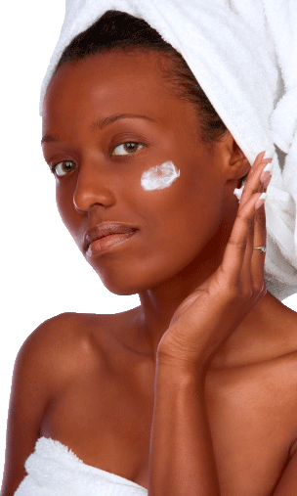

Vocab Canvas
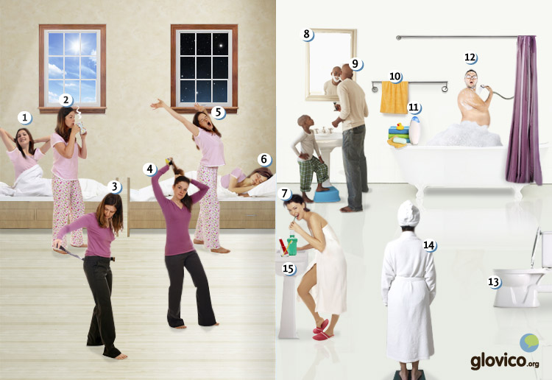

Talking

Time Management II
Your professor takes up his role as time management coach again. After having gotten a first insight into a typical day of yours in chapter 4, he wants to dig deeper now to find more time for your language learning.

Thinking
- Take a minute again to think about the things that you do every day.
- Also think about the things that you do on a weekly, monthly or annual basis.
- Compare this lifestyle to the lifestyle of a travelling language student.

Talking
- Tell your coach about your current daily, weekly, monthly and annual routines.
- Contrast these with the routines of the traveller.

Optional
- Think again about three things that you would like to include in your daily routine.

Story telling
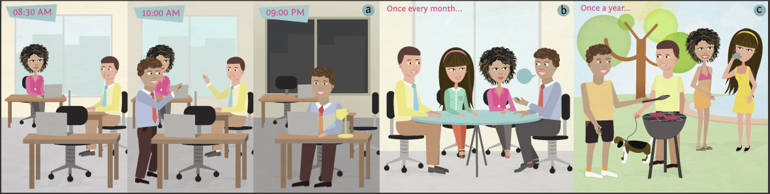

Writing

Write a blog post about a typical day in your life
Due to your frequent online reviews and blog posts you have become quite popular in the blogosphere. Even on the untouched island of Palulauloa you have a number of readers that are highly interested in your life and ask you to write a blog post about a regular day of yours. You are so intimidated by this popularity that you cannot decline. As Palulauloaians lead a lifestyle very different from anywhere else in the world make sure to include all the details of your day that might in other contexts be neglected. Also make sure to include comparisons to a typical resident of your country to allow the Palulauloaians to judge how representative your lifestyle is for your country.

Preparation
- Review the vocabulary for daily activities and select a range of activities (at least 10) to include in your blog post.
- Think about how your day compares to the typical day of someone living in your country.

Writing
- Start off by explaining your typical morning routine (e.g., When do you get up? What do you do first?) and continue through the afternoon and evening.
- Compare your day to the typical day of someone living in your country whenever it might be interesting (e.g., I get up much earlier than most people.).

Review
- Check your spelling.
- Check whether you have used some of the structures you learnt in this lesson.
- Once you are happy with your blog article, send it to your teacher so he or she can review it.

Reading

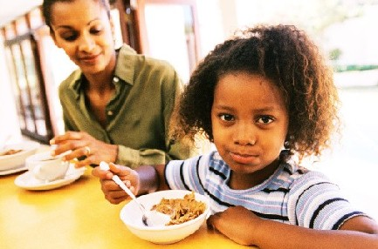

Una mañana en la vida de la familia Ponzo
Todos los días de la semana Juan Ponzo se despierta más temprano que el resto de su familia. Se levanta a las siete de la mañana. Primero va al baño para ducharse. Luego se afeita y se cepilla los dientes. A las siete y media despierta a su mujer Ana. Entonces los dos toman un café juntos y después Juan sale de la casa.
Luego Ana se viste, se peina el pelo y se maquilla. A las ocho y cuarto despierta a sus hijas. Tienen cinco y siete años y ya saben vestirse solas. Ana prepara el desayuno. Después lleva a sus hijas a la escuela y va a trabajar.

Y una tarde en la vida de la familia Ponzo
A las cuatro de la tarde las hijas de la familia Ponzo salen de la escuela. Sus padres todavía están trabajando, entonces las niñas van a casa de sus abuelos. Sus abuelos tienen un jardín más grande que sus padres, por eso las niñas quieren mucho pasar tiempo allí. Como siempre su padre pasa a buscar a sus hijas a las seis. A veces sus hijas tienen muchas ganas de comer un helado y los tres van a una heladería que está en camino a su casa.
Este lunes tienen que hacer las compras. Necesitan papel higiénico, champú y unas toallas. En la tienda hay poca gente, por eso regresan a las seis y media. Ana todavía no está en casa, nunca regresa tan temprano como su marido. A las ocho regresa y la familia cena. Luego sus hijas se acuestan y los padres miran una película. Toda la familia duerme a las diez.

Culture

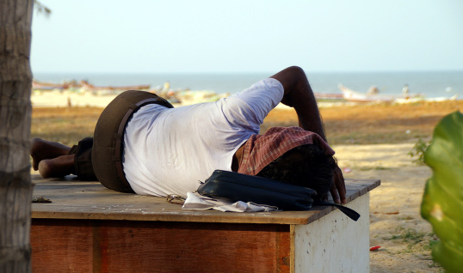

La Siesta
The Spanish-speaking world is known for a daily ritual that more Northern countries lack: the siesta. That short nap taken after lunch in the early afternoon is common in the warmer countries and helps both with digestion as well as fleeing the mid-day heat. But also less hot spots such as Southern Chile's Patagonia practice the Siesta.
Disregarding the fact that a number of modern studies point out the healthiness of this practice and its contribution to longevity the siesta has seen a decline in recent years. Particularly due to economic pressures a lifestyle has gained in drive which holds no place for the mid-day nap.
If you consider reviving it, note the following important items to enjoy the full pleasure of a Siesta:
- Have a nice lunch with friends or family.
- Put on pajamas as if preparing for night's sleep and have the siesta in bed. As an alternative a very comfortable couch is also fine.
- For perfect relaxation aim for between 15 and 30 minutes.
- Make sure that telephones are off and nothing disturbs you.
- Finally, have an alarm set so you don't have to worry about when to get up again!

Grammar

Reflexive pronouns and verbs
When the action of the verb in a sentence is received by the subject of the sentence, it is a reflexive action. For example, "I wash myself" is a reflexive action, whereas "I wash the child" is not reflexive. In Spanish, many of the verbs related to body care are reflexive (vestirse - to get dressed, lavarse - to wash oneself, peinarse - to comb one`s hair, bañarse - to bathe).
Reflexive verbs require reflexive pronouns.
Subject pronoun | Reflexive Pronoun | Verb (vestirse)
yo | me (myself) | visto
tú | te (yourself) | vistes
él, ella, usted | se (himself, herself, yourself) | viste
nosotros/as | nos (ourselves) | vestimos
vosotros/as | os (yourselves) | vestís
ellos/as, ustedes | se (themselves, yourselves) | visten
The reflexive pronouns have the same forms as the direct object pronouns that you learnt previously except for the third person singular and plural.
As the direct object pronouns, the reflexive pronouns precede the conjugated form of the verb.
Mariana se peina todas las mañanas. | Mariana combs her hair every morning.
Los niños se lavan. | The children wash themselves.
And also similar to the direct object pronouns, in sentences that use the infinitive of a verb, the relative pronouns can either precede the conjugated form of the verb or be attached to the infinitive.
Me quiero bañar. | I want to take a bath.
Quiero bañarme. | I want to take a bath.

Comparison of inequality

Más/menos + adjective/adverb/noun + que
To compare persons or objects that are different from each other, you use the comparative. There are two constructions in Spanish: more ... than and less ... than.
más + adjective/adverb/noun + que | more ... than
menos + adjective/adverb/noun + que | less ... than
You can use this with adjectives, adverbs, and nouns.
Adjective
Hugo es más listo que Fabio. | Hugo is smarter tan Fabio.
Estoy menos cansada que mi amiga. | I`m less tired than my friend.

Adverb
Mañana me voy a levantar más temprano que hoy. | Tomorrow I will get up earlier than today.
Mi abuela va venir menos tarde que mis primas. | My grandmother will arrive earlier than my cousins.

Noun
Tengo más hijos que tú. | I have more children than you.
Conoce menos gente que su mujer. | He knows less people than his wife.

Special comparative forms of adjectives
You know from English that a few adjectives take a special form when making comparisons (bad -> worse, good -> better). The same is true for Spanish adjectives, the following adjectives take a special form.
alto (tall, high) | superior (taller, higher)
bajo (short, low) | inferior (shorter, lower)
bueno (good) | mejor (better)
malo (bad) | peor (worse)
grande (big) | mayor (bigger)
pequeño (small) | menor (smaller)
When using these adjectives in a comparison, you leave out the más or menos.
Esta casa es menor que la otra. | This house is smaller than the other one.
Este restaurante es mejor que el restaurant de Paco. | This restaurant is better than Paco`s restaurant.
Note that you can use both the special and the regular comparison for grande and pequeño. Major and menor are usually used when talking about the age of somebody. For example:
Soy major que mi hermana. | I`m older than my sister.
Mi madre es menor que mi padre. | My mother is younger than my father.
When taking about the size of something they are usually used in their regular form. For example:
Mi casa es más grande que la casa de mi hermana. | My house is bigger than my sister`s house.
El baño es más pequeño que la cocina. | The bathroom is smaller than the kitchen.

Special comparative forms of adverbs
Similarly to the special forms that some adjectives take when making comparisons, there are a few adverbs that take a special form.
bien (well) | mejor (better)
mal (badly) | peor (worse)

Comparisons of equality

With adjectives/adverbs: tan + adjective/adverb + como
To make comparisons of equality with adjectives or adverbs in Spanish, for example if you want to say "I`m as tall as John." or "He runs as fast as Tom.", you can use the following construction.
tan + adjective/adverb + como | as ... as
Below you find some examples for using this construction with adjectives and adverbs.
Adjective
Hugo es tan alto como Fabio. | Hugo is as tall as Fabio.
Estoy tan responsable como tú. | I`m as responsible as you.

Adverb
Mañana me voy a levantar tan temprano como hoy. | Tomorrow I will get up as early as today.
Mi abuela va venir tan tarde como mis primas. | My grandmother will arrive as late as my cousins.

With nouns: tanto/a/os/as + noun + como
To make comparisons of equality with nouns, for example to say "I have as many friends as Tom.", you can use the following construction.
tanto/a/os/as + noun + como | as ... as
Below you find some examples for using this construction with nouns. Note that tanto agrees in number and in gender with the noun.
Noun
Hugo tiene tantos niños como Fabio. | Hugo has as many children as Fabio.
Vamos a escuchar tantas canciones como ayer. | We will listen to as many songs as yesterday.

With verbs: verb + tanto como
To make comparisons of equality with verbs, for example to say "They know as much as we do." or "I like him as much as you do.", you can use the following construction.
verb + tanto como | ... as much as
Below you find some examples for using this construction with verbs.
Verb
Saben tanto como nosotros. | They know as much as we do.
Me gusta tanto como a Maria | I like it as much as Maria.
Top of Form
Vocbulary
Spanish | English
despertarse (ie) | to wake up
levantarse | to get up
vestirse (i) | to get dressed
peinarse | to comb
bañarse | to bathe
ducharse | to shower
afeitarse | to shave
cepillarse (los dientes) | to brush one`s teeth
lavarse | to wash
acostarse (ue) | to go to bed
maquillarse | to put on makeup
dormirse (ue) | to fall asleep
la cara | face
los dientes | teeth
el pelo | hair
la mano | hand
el espejo | mirror
la toalla | towel
la ducha | shower
el jabón | soap
el lavamanos | sink
el baño | bathroom
el champú | shampoo
el cepillo (de dientes) | (tooth) brush
el desodorante | deodorant
el peine | comb
la máquina de afeitar | electric razor
el secador | hair dryer
la bata de baño | dressing gown
la cama | bed
la ropa | clothes
temprano | early
tarde | late
demasiado | too (much), enough
antes | before
más | more
menos | less
regresar | return
todavía | still
necesitar | to need
por eso | therefore
normalmente | normally, usually
pasar a buscar | to fetch
el paper higiénico | toilet paper
la escuela | school
el helado | ice cream
la heladería | ice cream shop
la tienda | shop
el supermercado | supermarket
el servicio | toilet
siempre | always
nunca | never
a veces | sometimes
el resto | rest

