Lesson 7

Vacation Vacaciones

In this lesson you learn to
- Discuss and describe future plans
- Express preferences and desires
- Plan to get to your next destination
  - Buy tickets
  - Ask for and respond to simple directions
  - Talk about using different modes of transportation
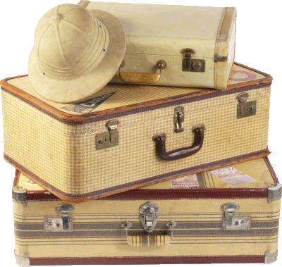

Vocab Canvas
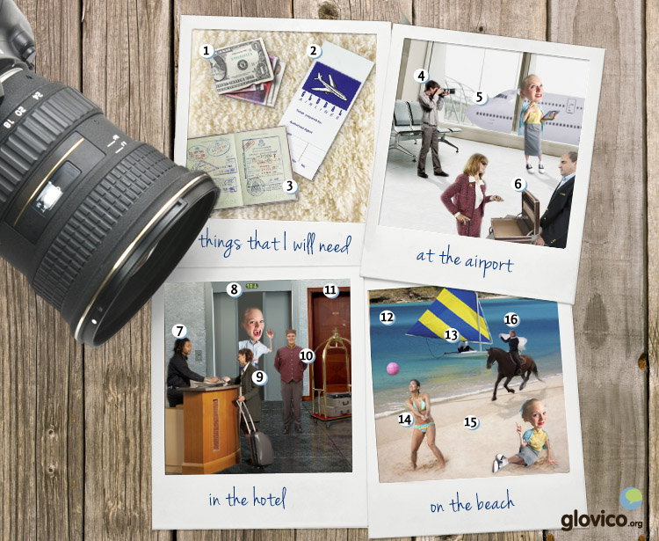

Talking

Travel Arrangements
Your professor is a travel agent whom you are visiting to plan your next vacation.

Thinking
- Think about a destination that you always wanted to travel to.
- Furthermore make some plans on how to travel (biking, hiking, renting a car, public transport, etc.) and things that you want to see.

Talking
- Tell the travel agent abour your plans.
- Ask about prices and availability or various modes of transportation (bus, plane, ship etc.) as well as available rooms in ho(s)tels.

Optional
- Start bargaining about the prices.

Story telling
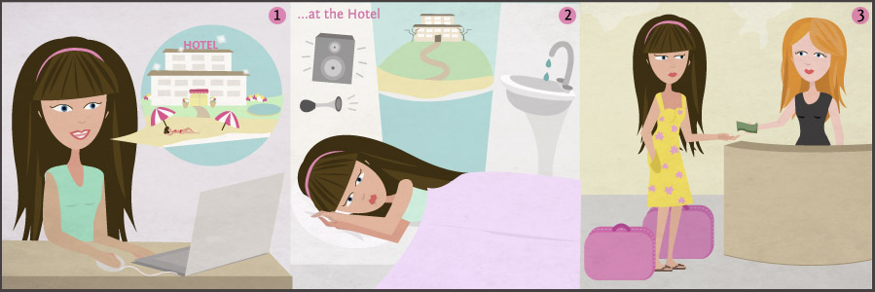

Writing

Write a hotel review
Write a review of a hotel that you visited at some point in the past. Imagine you write the review for a website that caters to people who don`t know a lot about the area in which the hotel is located. So make sure to describe the hotel as well as the area in your review.

Preparation
- Think about adjectives that describe your experience at the hotel.
- Make a list of activities and nearby places that you would recommend to visitors.

Writing
- Introduce the hotel (location, price, typical visitors, etc) and review your experience.
- Explain what activities, interesting places and restaurants are close to the hotel and recommend your favorites.
- Describe to the reader how you get to the hotel and which modes of transportation you have to use.
- Make an overall recommendation for or against the hotel. Would you stay there again in the future?

Review
- Check your spelling.
- Check whether you have used the new vocabulary and structures you learnt in this lesson.
- Once you are happy with your hotel review, send it to your teacher so he or she can review it.

Reading

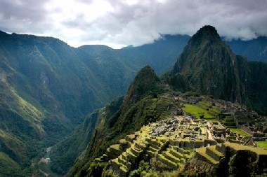

¿Quieres ir a Machu Picchu?
Maruja y su prima Beatriz quieren viajar durante el verano. Viven en Lima, Perú.
Maruja: Prefiero ir a un lugar cerca de Lima. No me gusta viajar mucho tiempo.
Beatriz: ¿Qué tal mi idea: viajamos primero a Machu Picchu y luego a Bolivia?
Maruja: ¿Podemos ir en autobús?
Beatriz: En autobús son 22 horas. Prefiero en avión, es solamente una hora y media hacia Cuzco. Allí empiezan las excursiones a Machu Picchu.
Maruja: Vale. ¿Cuánto cuesta el vuelo?
Beatriz: Más o menos 400 soles.
Maruja: Ah, no es demasiado y me gusta volar. Entonces vamos a tomar el avión a Cuzco y luego podemos tomar el autobús para Bolivia.
Beatriz: ¿Tú quieres hacer el sendero de los Incas a Machu Picchu? Hay que andar 4 días de Cuzco a Machu Picchu.
Maruja: ¡Andar 4 días! Parece muy cansado.
Beatriz: Tienes que mirar las fotos de Jorge. Son muy impresionantes.
Maruja: Voy a mirar sus fotos esta tarde. Luego voy a decidir.
Beatriz: ¿Entonces tenemos que reservar los billetes para el avión ahora?
Maruja: Vale. Voy a buscar mi tarjeta de crédito. Además debemos reservar una habitación doble en un hotel en Cuzco. Durante las vacaciones hay muchos turistas en la ciudad.
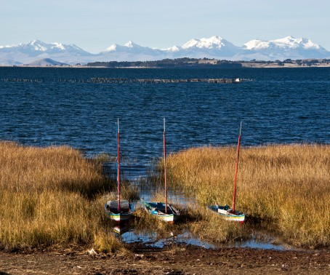

Tomamos el autobús
Después de Machu Picchu, Maruja y Beatriz quieren visitar Bolivia. Hacen sus maletas en el hotel y toman un taxi a la estación de autobuses de Cuzco.
Beatriz: Tenemos que ir a Puno primero. Es una ciudad cerca del lago Titicaca. Desde allí hay conexiones a Bolivia.
Maruja: ¿Dónde venden los billetes?
Beatriz: No sé. Voy a preguntar. Disculpe señor, ¿En dónde podemos comprar los billetes?
Hombre: ¿Adónde van?
Beatriz: Queremos ir a Puno.
Hombre: Entonces es la compañía Pullman. Van primero todo recto y detrás del quiosco a la izquierda. Allí en la segunda ventanilla pueden encontrar la compañía Pullman.
Beatriz: Muchas gracias.
Hombre: De nada.
En la ventanilla de la compañía Pullman.
Maruja: Buenos días. Queremos comprar dos billetes a Puno.
Vendedora: ¿A qué hora quieren salir?
Maruja: ¿A qué hora sale el proóximo autobús?
Vendedora: A las dos y media. ¿Ida y vuelta?
Maruja: Sólo ida.
Vendedora: Bueno. ¿Cómo van a pagar? ¿En efectivo o con tarjeta?
Maruja: Pago en efectivo. ¿Cuánto es?
Vendedora: Son 40 soles. Aquí tienen los billetes. Van a embarcar en el andén número 11.

Culture

El fin del mundo
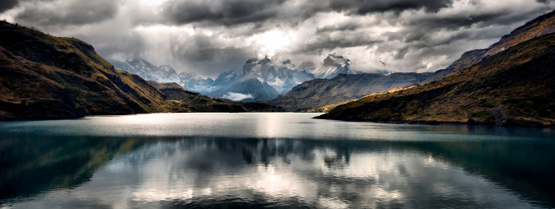
The South of Chile and Argentina - known as Patagonia - hosts some natural beauty that attracts thousands of tourists from all around the globe every year. Whether you are looking for beautiful hikes, horseback riding, rafting or the pleasures of a good meal, Patagonia will definitely excite you. With the giant Andes on one side and the ocean on the other side you can make your way down to Cape Horn. Before the Panama Canal was built in 1914, the Cape was part of the major naval trading routes around the globe (and feared by sailors for its hazardous conditions). Today it is still one of the challenges in several big yachting races. While the Patagonia region lost a lot of economic importance through the Canal it has gained its touristic reputation.

Pucón
Known for its volcano as well as its opportunities for rafting this is probably the center for adventure outdoor sports in the region. But not only that: some hot springs allow the adventurers to soak in scenic beauty after the adventures of the day.

Puerto Montt/ Puerto Varas
Located 1000 km South of Chile's capital these twin cities are the gateway to the Chiloe peninsula as well as the home to a large part of the Germany-rooted population of Chile. They are renowned for their seafood and their Kuchen (German-style pastry) has a great reputation throughout Chile. The cities serve as entry-points to beautiful hikes around the area and are a little quieter and more reclusive than Pucón.

Torres del Paine
Even further in the South finally looms the National Park 'Torres del Paine' which is known by hikers and climbers for its raw beauty and untouched nature. Fjords, snow-covered mountain peaks, glaciers, there is a lot to be discovered on foot or horseback in the park. But better bring some good equipment: weather can change quickly down there. Yet, looking out over a huge glacier in the sunshine after a hike full of scenic views shows you again the beauty that nature can hold.
So maybe the end of the world is not that bad after all.

Grammar

Future actions or plans: Ir a + infinitive
To express that an action will start soon, you can use ir a + infinitive. For example:
Voy a llegar pronto. | I will arrive soon.
Vamos a salir en media hora. | We will go out in half an hour.
Apart from describing actions that will take place in the near future, ir a + infinitive is also used to express plans for the future.
Este año vamos a viajar a Perú. | This year we will travel to Peru.
Van a estudiar en Buenos Aires. | They will study in Buenos Aires.

Obligation or recommendation: Deber + infinitive
To express a moral obligation, you can use deber + infinitive. For example:
Los padres deben jugar con sus niños. | Parents should play with their children.
Additionally, you can use deber + infinitive to express a recommendation. For example:
Debes hablar con tu madre hoy. | You should talk to your mother today.

More on verbs

Stem-changing regular verbs: o -> ue and e -> i
You know how to form the present tense of the regular verbs that end in -ar, -er and -ir. There are also three groups of verbs in Spanish that change stem vowel in the present form, except for nosotros/as and vosotros/as. You already know the verbs that change e -> ie, now you learn the other two cases, o -> ue and e -> i.

o -> ue
poder (can, to be able to)
Yo | puedo
Tú | puedes
Él/ella/usted | puede
Nosotros/as | podemos
Vosotros/as | podéis
Ellos/as, Ustedes | pueden
Other verbs that have the same change in stem vowel: volar, volver and encontrar. Jugar has a similar change, u -> ue. For example:
Juego al fútbol.

e -> i
servir (to serve)
Yo | sirvo
Tú | sirves
Él/ella/usted | sirve
Nosotros/as | servimos
Vosotros/as | servís
Ellos/as, Ustedes | sirven
Other verbs that have the same change in stem vowel: repetir and pedir.

Verbs with an irregularity in the first person singular
Besides the regular -ar, -er and -ir verbs and the stem changing verbs, there are a number of irregular Spanish verbs that only exhibit an irregularity in the first person singular. You already learnt ver and hacer, today you learn a few others.
ver (to see) | Yo | veo
hacer (to do) | Yo | hago
saber (to know) | Yo | sé
salir (to go out, to leave) | Yo | salgo
poner (to put, to place) | Yo | pongo
dar (to give) | Yo | doy

- See more at: http://www.glovico.org/syllabus/Spanish/lesson7/grammar#sthash.W1Jbunc6.dpuf
Vocbulary
Spanish | English
el dinero | money
el pasaporte | passport
el billete | ticket
el viajero | traveller
el avión | plane
el equipaje | luggage
facturar el equipaje | to check the luggage
embarcar | to board
el vuelo | flight
la conexíon | connection
la recepción | reception
el huésped | guest
la habitación | room
libre | free
la habitación doble | double room
la habitación individual | single room
reservar | to book
el portero | doorman
el mar | sea
la playa | beach
ir a caballo | ride a horse
el voleibol | volleyball
navegar a vela | to sail
costar | to cost
hacer la maleta | to pack
olvidar | to forget
volar | to fly
poder | can, to be able to
volver | to return
repetir | to repeat
pedir | to ask for
servir | to serve
encontrar | to find
todo | all
poco | little, not much
bastante | enough, quite (some)
cerca (de) | close (to)
lejos (de) | far (from)
al lado de | next to
enfrente de | opposite, in front of
detrás de | behind of
encima de | on top of
debajo de | under
delante de | in front of
además | moreover, in addition
preferir | to prefer
durante | during
solamente | only
hacia | to, towards
mostrar | to show
la tarjeta | card
la tarjeta de crédito | credit card
desde | from
el quiosco | kiosk
pagar | pay
la ventanilla | counter
en efectivo | cash
ida y vuelta | round trip
la ida | outward trip
vender | to sell
el andén | platform
salir | to go out, leave
deber | must
las vacaciones | holidays
el turista | tourist
saber | to know
poner | to put, to place
dar | to give
solo/a | alone
la compañía | company
más o menos | more or less

