Lesson 6

Me, Myself & I Yo y mis cosas

In this lesson you learn to
- Express and ask about physical states (hungry, thirsty) and emotions (happy, sad)
- Express and enquire about the ownership of things
- Describe the location of things

Vocab Canvas
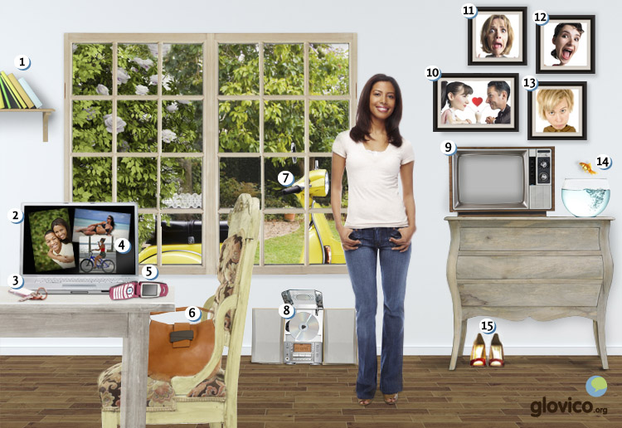

Talking

Moving
Having lived in a Bed & Breakfast for a few weeks in your new country of residence you finally decide to move to your own place. While the landlady of the Bed & Breakfast is generally a very pleasant person she is also very moody and sometimes happy, sometimes sad.
As you already found a great furnished apartment that you will move into in a few weeks you get in touch with an agency to help you move. They ask you about all the items that you have and intent to move as well as their characteristics (whether they are big or small, old or new, heavy or light). After having gone through all the items you start chatting a bit with the owner of the agency and start complaining about the lady of the Bed & Breakfast.

Thinking
- Take a minute to think about all the items that you would probably have to move if you had just relocated to a new country.
- In case you did not consider to bring your huge TV, your old CD player and a large collection of books to your new country, you just redecided and have these items amongst the things to move.

Talking
- Tell the agency owner about all the items that you intent to move.
- Gossip a bit about the owner of the Bed & Breakfast that you are currently staying in.

Optional
- Describe the owner of the agency the way to your new address from the Bed & Breakfast.

Story telling

Writing

Write a letter to your aunt
Closely following the increase in your blogging and setting up websites an aunt of yours is mad that she hasn't received a letter from you in a several months and doesn't know how you are doing in your new home. You decide to send her an update.

Preparation
- Collect a list of adjectives of your current state (both emotionally as well as physically).
- Set up a list of items that are very important to you.

Writing
- Write a short letter to a fictional aunt assuming that you had moved to a new country a few months ago.
- Include a few sentences to describe the owner of the Bed & Breakfast that you stayed in for the first few weeks.

Review
- Check the spelling of your paragraph.
- Have you included a rich variety of adjectives?
- Then send the paragraph to your teacher before your next lesson so that he or she can review it.

Reading

Compañeros de piso
Fernando estudia en Granada en Andalucía en España. Vive con dos amigos en un piso en el centro de la ciudad. En este momento hay muchos problemas en el piso, porque Fernando quiere vivir con su novia Ana. Sus amigos están muy deprimidos.
Amigo 1: Estoy triste. Fernando es un buen amigo y me gusta vivir con él.
Amigo 2: Tenemos que buscar un nuevo compañero de piso. Pero es noviembre. Tengo miedo porque los estudiantes ya tienen apartamentos. Buscan en septiembre.
Amigo 1: Tienes razón. Tenemos que hablar con Fernando.
Amigos: Fernando, queremos tomar una cerveza contigo, ¿cuándo tienes tiempo?
Fernando: En una hora. Quiero beber algo con vosotros. ¿Tenéis hambre también?
Amigos: Sí.
Fernando: Entonces preparo comida. Y ahora, tomamos mi televisión y el reproductor de CD. El reproductor es ligero, pero la televisión es pesada. Quiero llevar mis cosas al piso de Ana ahora. Mi coche está allí en la calle y aquí tenéis la llave.
Amigos: Vale. ¡Pero tienes que comprar las cervezas!

¿Adónde viajamos este año?
Marina es una chica alta, morena y alegre. Su novio Paco es muy divertido y alto también. Están en casa de su amigo Juan y miran fotos en el portátil.
Marina: Tengo ganas de mirar las fotos de nuestras vacaciones en Colombia.
Paco: Aquí están estas fotos. ¡Qué bonita! Mira esta foto, estamos en la moto de tu tía y vamos a la playa. Sus hijos están tristes porque quieren ir con nosotros.
Marina: Esa foto es muy divertida, los niños quieren jugar al fútbol y tú tienes mucho sueño.
Paco: Estoy feliz. Me gusta mucho ver estas fotos. Tenemos que viajar otra vez. ¿Qué piensas?
Marina: Tienes razón. ¿Pero, adónde?
Paco: Juan tiene muchos libros. Juan, ¿dónde están tus libros sobre los países exóticos?
Juan: Esos libros están allí, a la izquierda de la televisión.
Paco: Muchas gracias. ¿Con qué libro quieres empezar, Marina?
Marina: Quiero empezar con este libro sobre Asia.

Culture

Famous Latinas
Despite being known as the continent of the "machismo", Latin America actually had and has a number of very important female figures throughout its history particularly in the area of arts and politics. And they are not only in one place, no you find them all over the continent ranging from the north (Mexico and Guatemala) to the south (Chile and Argentina).
In Mexico artist Frida Kahlo (1907- 1954) who is mostly known for her self-portraits became an icon of depicting Mexican mythology and blending it with Jewish as well as Christian elements. She was born and died in Mexico City in her home called the Blue House. Apart from giving artistic expression to the indigenous culture of Middle America, she is also famous for her paintings of femininity.
Also from Middle America but active half a century later, Rigoberta Menchú Tum gives a voice to the indigenous peoples of that region. Born in 1959 in Guatemala, she received the Nobel Peace Prize in 1992 for her activities to defend human rights. She experienced the injustice of the indigenous population living in poverty from first hand as her family was assassinated by the Guatemaltecian regime in 1980.
In the South, María Eva Duarte de Perón aka "Evita" (1919 - 1952) from Argentina is not only known as the second wife of Argentina’s former president Juan Perón but as a person of political life of her own. In particular she was a strong proponent of labor rights and the prime leader of the women’s suffrage movement in Argentina. In 1996 her biography was made a movie starring Madonna as Evita.
Further to the west and again almost half a century later, Isabel Allende is one of the most famous writers of Chile. She was born in 1942 in Peru but is inextricably tied to Chile as her father was a cousin of former Chilean president Salvador Allende. Her novels are sold all around the world and are famous for their magic realism. Most known is her novel "The House of the Spirits" telling the story of several generations of a family in post-colonial Chile.

Grammar

Adjectives

Expression possession: Possessive adjectives
 | Singular | Plural | English
Yo | mi | mis | my
Tú | tu | tus | your
Él/ella/usted | su | sus | your, his, her
Nosotros/as | nuestro/a | nuestros/as | our
Vosotros/as | vuestro/a | vuestros/as | your
Ellos/as, Ustedes | su | sus | your, their
Possessive adjectives indicate to whom something belongs. The possessive adjectives agree in number with the noun they modify.
Mi madre es alta.
Mis amigas son guapas.
Only nuestro/a and vuestro/a additionally agree in gender with the noun.
Nuestros hijos tienen hambre.
¿Vuestras gatas también tienen miedo de los perros?

Indicating objects: Demonstrative adjectives
Demonstrative adjectives are used to point out people or objects. They indicate the location of the person or object relative to the speaker and addressee.
Gender | Singular | Plural | English
masculine | este | estos | this, these (close to speaker)
feminine | esta | estas
masculine | ese | esos | that, those (close to addressee)
feminine | esa | esas
masculine | aquel | aquellos | that, those (far from both, over there)
feminine | aquella | aquellas
Demonstrative adjectives usually precede the noun they modify to. They agree in number and in gender with the noun. For example,
Estos coches son azules.
Aquella es mi hija.
For each of the three types of demonstrative adjectives there are also related adverbs.
Demonstrative adjective | Adverbs | English
este/a | aquí | here
ese/a | allí | there
aquel/la | allá | over there

Verbs

Stem-changing regular verbs: e -> ie
You know how to form the present tense of the regular verbs that end in -ar, -er and -ir. There are also three groups of verbs in Spanish that change stem vowel in the present form, except for nosotros/as and vosotros/as.
querer (to want; to love)
Yo | quiero
Tú | quieres
Él/ella/usted | quiere
Nosotros/as | queremos
Vosotros/as | queréis
Ellos/as, Ustedes | quieren
Other verbs that have the same change in stem vowel: pensar, entender and empezar.

Wish or intention: Querer + infinitive
To express express a wish or an intention, you can use querer + infinitive. For example:
Quiero ir al cine. | I would like to go to the cinema.
Queremos comprar una casa. | We would like to buy a house.

- See more at: http://www.glovico.org/syllabus/Spanish/lesson6/grammar#sthash.KVi3CFEU.dpuf
Vocbulary
Spanish | English
tener frío | to be cold
el frío | cold
tener calor | to be hot
el calor | heat
tener sueño | to be sleepy
el sueño | dream
tener sed | to be thirsty
el sed | thirst
tener hambre | to be hungry
el hambre | hunger
tener miedo | to be afraid
el miedo | fear
tener razón | to be right
la razón | reason
tener ganas de... | to feel like...
enamorado/a | in love
la llave | key
el libro | book
el portátil | laptop
el móvil | mobile phone
el bolso | handbag
la foto | photo
la televiseón | TV
la moto | moped, scooter
el reproductor de CD | CD player
el pez dorado | goldfish
el zapato | shoe
bonito/a | pretty, nice
listo/a | clever
alto/a | tall, high
bajo/a | short, low
largo/a | long
corto/a | short, small
pesado/a | heavy
ligero/a | light
este/a | this
ese/a | that
aquel/aquella | that (more distant)
feliz | happy
triste | sad
enfermo/a | ill
contento/a | satisfied
mal | bad
regular | average, ok
deprimido/a | depressed
enojado/a | angry
alegre | cheerful
porque | because
¿Por qué? | Why?
querer | to want, to like/love
empezar (a) | to begin (to)
pensar (en) | to think (about)
la casa | house
el piso | apartment, floor
el problema | problem
el centro | center
ya | already
el compañero | mate
el compañero de piso | flatmate
la cerveza | beer
el apartamento | flat, apartment
algo | something
ahora | now
llevar | to take
la vez | time
otra vez | again
exótico/a | exotic

