Lesson5

Hobbies -Pasatiempos

In this lesson you learn to
- Talk about your hobbies
- Express and ask about likes and dislikes
- Discuss what you or others have to do

Vocab Canvas
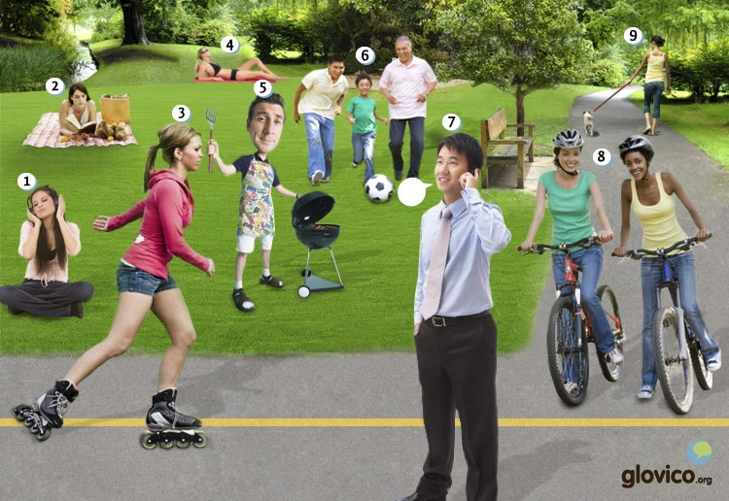

Talking

Making new friends
You are in a new city and a friend wants to introduce you to a number of people. In order to do so he wants to know about your hobbies. As you might imagine your professor is this friend.

Thinking
- Think about the things that you currently enjoy doing for leisure.
- Also think about some hobbies that you would like to try out.

Talking
- Tell your friend about the things that you currently pursue as hobbies.
- Include some further information on your likes and dislikes.

Optional
- Describe the typical day that you have in the new city.

Story telling
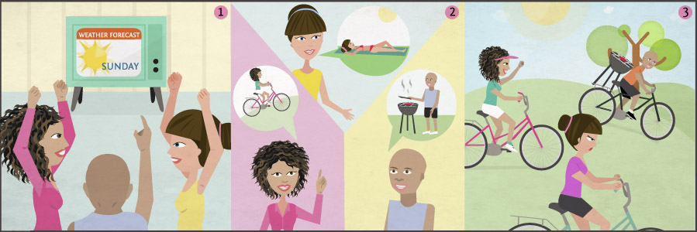

Writing

Write an internet page
You were elected as the head of social activities in a community of expats in a foreign country. Being unsatisfied with the job of the previous head you decide to write a fresh page about the various activities that are available in your new city of residence.

Preparation
- Think about the different groups your site should address: different age groups, genders and families/couples as well as singles.
- Pick at least 4 different groups you want to address.
- Think about a few activities that would be interesting for each group.

Writing
- Introduce yourself to the community.
- For each group that you want to address with your site write a paragraph introducing the top activities that are available for them.

Review
- Check your spelling.
- Review whether you used the whole range of activities that you already know.
- Once you are happy with your website, send it to your teacher so he or she can review it.

Reading

El fin de semana
Luís y Hugo son hermanos. Luís tiene 30 años y Hugo tiene 34 años. Ana es la novia de Hugo. Están en casa y hablan sobre el fin de semana.
Luís: ¿Qué hacemos hoy?
Hugo: A mí me gusta practicar deporte.
¿Jugamos un partido de fútbol? ¿O corremos en el parque?
Luís: No me gusta practicar deporte. Me gusta escuchar música o leer un libro.
Hugo: ¿No te gusta bailar o hacer una fiesta?
Luís: Sí. Me gusta bailar. ¿Hacemos una fiesta mañana por la noche?
Hugo: Me gusta. Tenemos que comprar bebidas.
Luís: Y tienes que hablar con Ana. Ella prepara comida muy buena.
Hugo: Vamos a ver. Está cansada, tiene mucho trabajo...
Luís: Bueno, entonces hacemos una barbacoa.
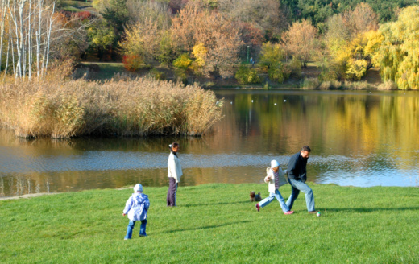

En el parque
La familia Alonso está en el parque. Es un domingo en otoño. Hay muchos árboles verdes, amarillos y rojos. Los padres caminan en el parque. Los hijos Nico y Tomás hablan con una amiga.
Nico: ¿Dónde está la bicicleta verde?
Ana: No sé. Tienes que mirar entre los árboles.
Nico: Vale.
Tomás: Me gusta jugar al fútbol. Ana, ¿qué te gusta hacer?
Ana: Me gusta nadar. Pero no hay una piscina cerca de aquí. También me gusta jugar al fútbol.
Tomás: Vale. Ahora jugamos al fútbol. Y por la tarde hay un concierto de rock.
Ana: ¡Qué bueno! Me gusta la música rock. ¿Dónde es el concierto?
Tomás: El concierto es en el parque, cerca del lago.

- See more at: http://www.glovico.org/syllabus/Spanish/lesson5/content#sthash.9G9iVkRl.dpuf

Culture

El fútbol

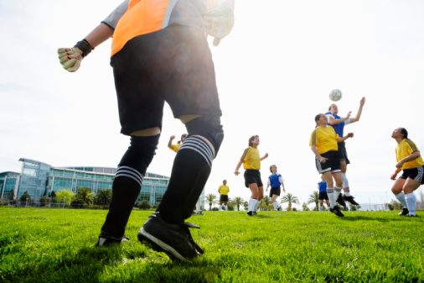
Latin Americans enjoy a number of sports but in most countries football is the most popular sport. Only in Venezuela baseball is more popular. South America is home to the longest running football tournament in the world: Copa América. It has run regularly since 1916. Some of the most famous players of the world come from the continent, including Pelé, Diego Maradona, Ronaldo, Ronaldinho, Kaká, and Lionel Messi.
What are the most popular sports in the country of your teacher?
What else do people usually do in their free time?

- See more at: http://www.glovico.org/syllabus/Spanish/lesson5/culture#sthash.GdUmBqe5.dpuf

Grammar

Expressing pleasure and obligation

Pleasure: Gustar

Gustar + infinitive
To express that you enjoy to do something, you can use the Spanish verb gustar + infinitive.
Me gusta nadar. | I like to swim.
Me gusta bailar con mis amigos. | I like to dance with my friends.
To emphasize that you like something (which someone else might not like), you can include a mí in the sentence.
A mí me gusta nadar. | I like to swim.
To say that you don't like to do something, use no me gusta + infinitive.
No me gusta trabajar mucho. | I don't like to work a lot.
To ask someone whether they like to do something, you can you ¿Te gusta...?
¿Te gusta practicar tenis? | Do you like to play tennis?

Gustar + nouns
You can also use gustar to express that you like objects. In that case you use the following construction.
Me gusta(n) el/la/los/las + noun | I like + noun.
Note that you use the singular form gusta if you have a noun in the singular and the plural form gustan if you have a noun in the plural form.
Me gusta el coche de Ana. | I like Ana's car.
Me gustan los restaurantes baratos. | I like cheap restaurants.
Me gusta la música rock. | I like rock music.
Me gustan las flores. | I like flowers.

Obligation: Tener que + infinitive
If you want to express that you have to do something, a useful expression in Spanish is tener que + infinitive.
Tengo que trabajar el lunes. | I have to work on Monday.
Tenemos que comprar comida. | We have to buy food.
Tienen que estudiar los fines de semana. | They have to study on the weekend.

To be: Ser y estar
The English verb to be can be translated both by ser and by estar. However the two Spanish verbs are used in different contexts and cannot be interchanged.

Uses of ser
In general ser is used to identify people and objects.
¿Quién es? | Who is it?
¿Quién es ella? | Who is she?
Es una mujer. | It's a woman.
¿Qué es eso? | What is that?
Es un libro. | It's a book.
Furthermore ser is used to talk about :
Origin/Nationality
Soy de Perú. | I'm from Peru.
Soy alemana. | I'm German.

Occupation/work
Soy profesora. | I'm a teacher.

Relationsships
Ana es mi abuela. | Ana is my grandmother.

Ownership
Es mi libro. | It's my book.

Date/time
¿Qué hora es? | What time is it?
Son las tres. | It's three o'clock.
¿Qué día es hoy? | What day is today?
Hoy es martes. | Today is Tuesday.
Es verano. | It's summer.

With adjectives to express the characteristics of a person or object.
La tía es morena. | The aunt is brunette.

Location where/when an event takes place
La fiesta es en la casa de Ana. | The party is in Ana's house.
Es a las ocho. | It's at eight.

Uses of estar
Estar is used to identify the location of people or objects.
Maya está en casa. | Maya is at home.
El cine está a la derecha de la estación de autobuses. | The cinema is on the right of the bus station.
With adjectives estar is used to talk about the state/condition somebody is in.
¿Cómo está usted? | How are you?
Estoy bien. | I'm fine.
Las mujeres están tristes. | The women are sad.

Irregular verbs
estar (to be)
Yo | estoy
Tú | estás
Él/ella/usted | está
Nosotros/as | estamos
Vosotros/as | estáis
Ellos/as, Ustedes | están

ver (to see)
Yo | veo
Tú | ves
Él/ella/usted | ve
Nosotros/as | vemos
Vosotros/as | veis
Ellos/as, Ustedes | ven

- See more at: http://www.glovico.org/syllabus/Spanish/lesson5/grammar#sthash.qNRwMHfG.dpuf
Vocbulary
Spanish | English
escribir | to write
escuchar | to listen
leer | to read
mirar | to look at
nadar | to swim
correr | to run
comer | to eat
comprar | to buy
bailar | to dance
viajar | to travel
ver | to see
visitar | to visit
preparar | to prepare
caminar | to walk
tomar el sol | to take a sunbath
hablar por teléfono | to speak on the phone
el fútbol | football
el partido | game
el deporte | sport
la natación | swimming
la música | music
la comida | food
la bebida | drink
el museo | museum
el concierto | concert
la televisión | TV
la fiesta | party
el libro | book
la revista | magazine
tener que (+ infinitive) | to have to (+ infinitive)
Me gusta (+ infinitive) | I like to (+ infinitive)
Te gusta (+ infinitive) | You like to (+ infinitive)
gustar | to like
el parque | park
practicar | to practice/do (a sport)
estar | to be
cansado/a | tired
sobre | about
una barbacoa | BBQ
Vamos a ver. | We'll see.
No sé. | I don't know.
la piscina | swimming pool
cerca (de) | close (to)
aquí | here
el lago | lake
- See more at: http://www.glovico.org/syllabus/Spanish/lesson5/vocapp#sthash.gaYpxf6o.dpuf

