Lesson4

El tiempo

In this lesson you learn to
- Understand and express dates
- Ask for and tell time
- Count from 11 - 100
- Identify colors and talk about your favorite color
- 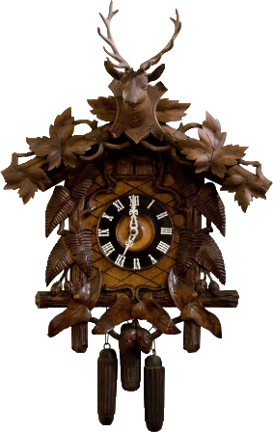

Vocab Canvas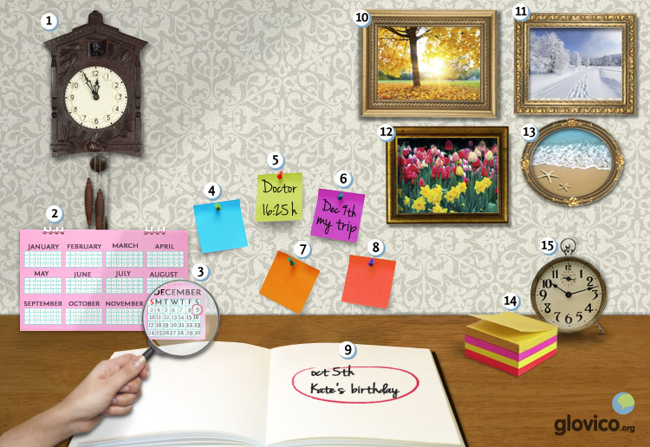

Talking

Time Management
Your professor amazingly turns out not only to be a language teacher but also a time management coach. As your language learning takes up more and more of your time you decide to give it a try and ask him for help. In a first step he assesses your current day to get a better idea of your lifestyle.

Thinking
- Take a minute to think about the things that you do every day.

Talking
- Tell your coach know when you get up, when you have your breakfast, when you go to work/ university, when you have lunch, when you return home, when you go to meet friends, etc.
- Being very superstitious you decided a while ago never to do things on full hours and everything that you do in a day has to begin on a different minute of the hour.

Optional
- Think about three things that you would like to include in your daily routine.

Story telling
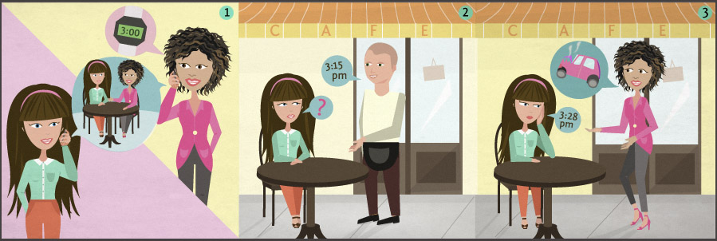

Writing

Write an email
Somebody from the very isolated island of Palulauloa read about you on an internet forum for language learning and got in touch with you as he is very interested in studying in your country for a few months. To get a better idea of when to come he asks you whether you could send him a description of what one could do each month of the year in your country.
Strangely enough he also asks you to write him about the predominant colors in nature each month. Seems like Palulauloa is very isolated indeed.

Preparation
- Review the names of the months and think about which colors in nature you associate with each month.

Writing
- Introduce yourself (age, origin, etc.).
- Write an email to the person from Palulauloa.
- For each month write a sentence or two about the activities you could do or the sites/cities you should visit.
- Don't forget to mention the colors in nature.

Review
- Check the spelling of your email.
- Did you use a range of activities and colors for the different months?
- Have you included a greeting and farewell?
- If you are happy with your email, send it to your teacher so he or she can review it.

Reading

Vamos al cine
Ana y Paula son hermanas. Viven en Madrid en España y estudian en la universidad. Hoy es sábado.
Ana: ¿Qué hacemos hoy?
Paula: Vamos al cine. Hay una película buena. Se llama "Trainspotting".
Ana: Buena idea. ¿A qué hora es la película?
Paula:"Trainspotting" es a las cinco menos cuarto o a las siete y diez de la noche. Ahora son las cuatro y media.
Ana: Pues vamos a las siete y diez. Ahora tomo un café con mi amigo Luís. ¿Y dónde está el cine?
Paula: Está en la calle Manoli, a la izquierda de la estación de ferrocarriles.
Ana: Vale. ¿Tomo la bicicleta roja?
Paula: Es mi bicicleta favorita. Pero entonces voy en el coche azul de Luís.
Ana: Gracias. Hasta luego.

Entre colegas
Diego trabaja en una empresa en Buenos Aires. Va a la cafetería con un colega. Beben café y hablan.
Colega: ¿Qué hora es?
Diego: Son las nueve menos cuarto.
Colega: ¿A qué hora llega el ejecutivo a Buenos Aires?
Diego: A las diez y media. Voy al aeropuerto en un taxi.
Colega: Por la tarde tengo una reunión con él.
Diego: ¿A qué hora?
Colega: A las tres.
Diego: ¿Cuándo trabaja esta semana?
Colega: Trabajo lunes, martes y miércoles en Buenos Aires.
Diego: ¿Qué hace jueves y viernes?
Colega: El jueves hablo con unos ejecutivos de Coca-Cola. Tenemos un proyecto con ellos. El viernes tengo otra reunión en Mar del Plata. Voy en autobús.
Diego: ¿Y qué hace el fin de semana?
Colega: El domingo es mi cumpleaños. Hacemos una fiesta en casa.

Culture

La Semana Santa

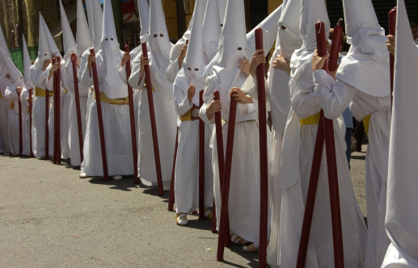
Easter is one of the highest holydays of the year in Spanish speaking countries. The week leading up to Easter (la Semana Santa) involves processions, prayers and masses to prepare for Jesus' rebirth. It is observed in Spain, Mexico and all over Latin America.
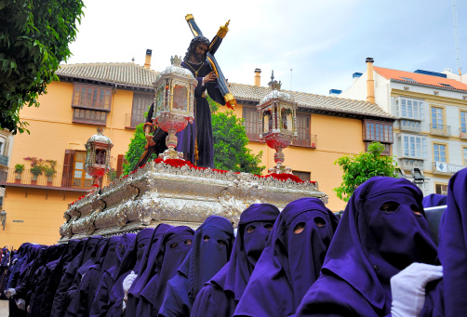Often the processions are very elaborate. In Andalusia in the South of Spain they are a long observed tradition. "Pasos" (lifelike sculptures made out of wood or plaster) model the scenes between Jesus' arrest and his burial. In some cities the sculptures are carried by penitents dressed in long robes with pointed hats. Some walk the streets barefoot and carry chains in their feet as penance.
What are the most important holidays in the country of your teacher? And how do you typically celebrate a birthday in the country of your teacher?

- See more at: http://www.glovico.org/syllabus/Spanish/lesson4/culture#sthash.RI2bByaD.dpuf

Grammar

Números (11 - 100)
The numbers from 0 until 29 are written in one word.
once | 11
doce | 12
trece | 13
catorce | 14
quince | 15
dieciséis | 16
diecisiete | 17
dieciocho | 18
diecinueve | 19
veinte | 20
veintiuno/a | 21
veintidós | 22
veintitrés | 23
veinticuatro | 24
veinticinco | 25
veintiséis | 26
veintisiete | 27
veintiocho | 28
veintinueve | 29
treinta | 30
cuarenta | 40
cincuenta | 50
sesenta | 60
setenta | 70
ochenta | 80
noventa | 90
cien | 100
From 30 to 99 the numbers (apart from the decimals) are written in three parts: the multiple of 10 + y + the multiple of 1.
treinta y tres | 33
cincuenta y cinco | 55

Talking about time: ¿Qué hora es?
To ask for and express what time it is, you use the Spanish verb ser. With una (one) you use 'es la', with all other times you use 'son las'.
Es la una. | It's one o'clock.
Son las dos. | It's two o'clock.
To express minutes after/past the full hour, use y.
Son las dos y veinte. | It's twenty past two.
To express minutes before the full hour, use menos.
Son las tres menos diez. | It's ten to three.
The words media and cuarto correspond to half and quarter in English.
Son las siete y media. | It's half past seven.
Son las ocho menos cuarto. | It's quarter to eight.
For noon and midnight, you have special expressions in Spanish
mediodía | noon
medianoche | midnight
To express a specific time you sometimes add de la mañana, de la tarde or de la noche.
Vamos al cine a las siete de la noche. | We go to the cinema at seven o'clock in the evening.
To express that something will take place in the morning, afternoon or evening without specifying when exactly, you can use por la mañana, por la tarde or por la noche.
Hablo con mis padres los domingos por la tarde. | Sunday afternoon I (usually) talk to my parents.

Verbs

Irregular verbs
ir (to go)
Yo | voy
Tú | vas
Él/ella/usted | va
Nosotros/as | vamos
Vosotros/as | vais
Ellos/as, Ustedes | van
Hacer has an irregular first person singular, the other forms of the present are regular.
hacer (to do)
Yo | hago
Tú | haces
Él/ella/usted | hace
Nosotros/as | hacemos
Vosotros/as | haceis
Ellos/as, Ustedes | hacen

Regular verbs: -er and -ir
Today, you learn all present tense forms for regular verbs that end in -er and -ir.

Regular -er verbs
Apart from beber, other regular -er verbs are: comer, comprender, prometer, vender.
beber (to drink)
Yo | beb + o | bebo
Tú | beb + es | bebes
Él/ella/usted | beb + e | bebe
Nosotros/as | beb + emos | bebemos
Vosotros/as | beb + éis | bebéis
Ellos/as, Ustedes | beb + en | beben

Regular -ir verbs
The regular verbs ending in -ir are very similar to the -er verbs, only the first (nosotros/as) and second (vosostros/as) person plural is different. Apart from vivir, other regular -ir verbs are: describir, escribir, imprimir, partir.
vivir (to live)
Yo | viv + o | vivo
Tú | viv + es | vives
Él/ella/usted | viv + e | vive
Nosotros/as | viv + imos | vivimos
Vosotros/as | viv + ís | vivís
Ellos/as, Ustedes | viv + en | viven
Vocbulary
Spanish | English
once | 11
doce | 12
trece | 13
catorce | 14
quince | 15
dieciséis | 16
diecisiete | 17
dieciocho | 18
diecinueve | 19
veinte | 20
veintiuno/a | 21
veintidós | 22
veintitrés | 23
veinticuatro | 24
veinticinco | 25
veintiséis | 26
veintisiete | 27
veintiocho | 28
veintinueve | 29
treinta | 30
cuarenta | 40
cincuenta | 50
sesenta | 60
setenta | 70
ochenta | 80
noventa | 90
cien | 100
el lunes | Monday
el martes | Tuesday
el miércoles | Wednesday
el jueves | Thursday
el viernes | Friday
el sábado | Saturday
el domingo | Sunday
enero | January
febrero | February
marzo | March
abril | April
mayo | May
junio | June
julio | July
agosto | August
septiembre | September
octubre | October
noviembre | November
diciembre | December
el año | year
el día | day
la semana | week
el invierno | winter
la primavera | spring
el verano | summer
el otoño | autumn
el cumpleaños | birthday
el tiempo | time
amarillo/a | yellow
rojo/a | red
azul | blue
verde | green
blanco/a | white
negro/a | black
gris | grey
naranja | orange
el reloj | watch/clock
el color | color
favorito/a | favorite
otro/a | another
¿Qué hora es? | What time is it?
el cine | cinema
la película | film
hacer | to do
ir | to go
vivir | to live
tomar | to take
el café | coffee
la cafetería | cafeteria
la reunión | meeting
llegar | arrive
beber | drink
el ejecutivo | manager/executive
el colega | colleague
la empresa | company
el fin de semana | weekend
entonces | then
vale | ok
estudiar | to study
la universidad | university
mediodía | noon
medianoche | midnight
la hora | hour
la noche | night
la mañana | morning
la tarde | evening
mañana | tomorrow

