Lesson3

Mi familia

In this lesson you learn to
- Talk about family and friends
- Describe persons and things
- Ask and respond to simple questions (who, what, when, from where)

Vocab Canvas
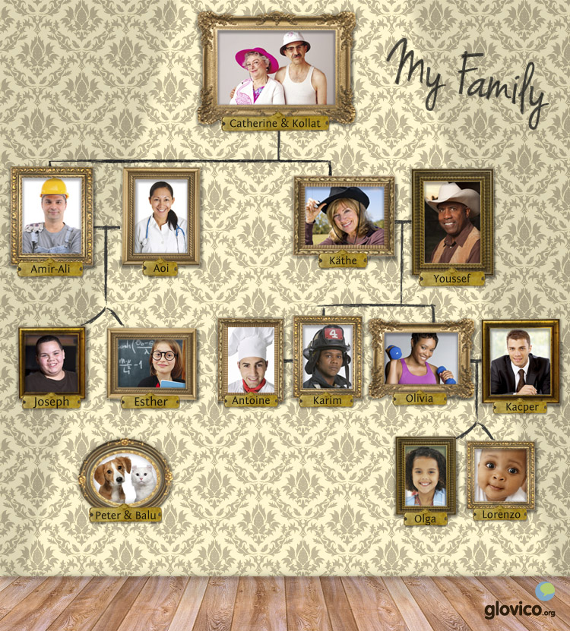

Talking

Dinner Party
Your professor is somebody you meet at a dinner party. Please introduce yourself and tell him about your family.

Thinking
- Take a minute to think about some adjectives that describe your family.
- Consider the appropriate forms to hold small talk at a dinner party.

Talking
- Get acquainted with your conversation partner at the dinner party.
- Introduce yourself.
- Tell him or her about your family.

Optional
- Hold some further small talk about the host.

Story telling
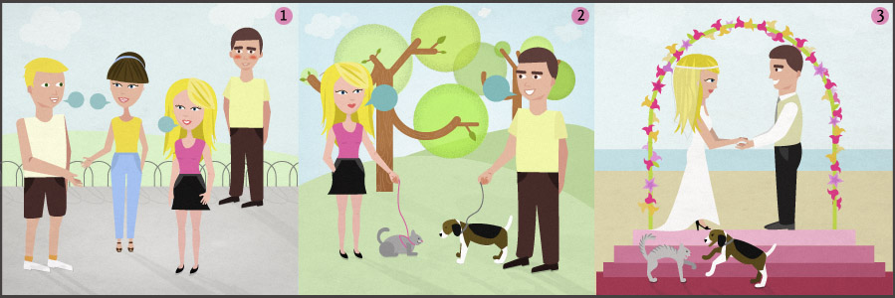

Writing

Write a blog post
One of the major blogs about the language that you are learning heard about you and is excited to publish an article about you. They ask you to write them a draft in which you talk about your family.

Preparation
- Collect a list of adjectives that you identify with yourself.
- Decide which of your family members to present (at least 3) and think about a few adjectives for each of them.

Writing
- Introduce yourself (age, origin, etc.).
- Describe yourself using the adjectives that you have gathered.
- Introduce at least 3 of your family members and describe some of their characteristics using the adjectives that you have gathered.

Review
- Check the spelling of your blog post.
- Have you included as many of the adjectives you already learnt as possible?
- Once you are happy with your blog post, send it to your teacher before your next lesson so that he or she can review it.

Reading

Mi familia
Somos una familia grande. Tengo una hermana y un hermano. Mi hermana se llama Isabel. Es morena y muy simpática. Tiene ocho años. Mi hermano se llama Luí:s. Tiene diez años y es tímido y un poco perezoso. Mi madre es morena y muy guapa. Mi padre es inteligente y muy extrovertido. Mis padres trabajan muchos. Mi abuelo tiene setenta años y es muy divertido.

La familia de Maya
Maya es una chica de Chile. Tiene una amiga, Ana. Ana estudia en Chile, pero es de España.
Ana: ¿De dónde son tus padres?
Maya: Mis padres son de Santiago. Tienen cuatro hijos y dos hijas.
Ana: ¿Cómo es tu hermana?
Maya: Es muy simpática y guapa. Estudia en Buenos Aires. Es muy extrovertida y tiene muchos amigos. Es soltera.
Ana: ¿Cuántos años tiene?
Maya: Tiene 25 años.
Ana: ¿Hablas mucho con tu hermana?
Maya: Sí, hablo mucho con ella.
Ana: ¡Qué interesante! ¿Hablas también mucho con tus hermanos?
Maya: No, pero un poco. ¿Y tú?

- See more at: http://www.glovico.org/syllabus/Spanish/lesson3/content#sthash.haS5rPU3.dpuf

Culture

La familia en los países hispanos
What role does your family play in your life?
How does that differ from Latin cultures?
Discuss with your teacher how families interact in his or her homecountry.

Grammar

Adjectives
Descriptive adjectives give additional information about people and objects (e.g., size, color). In Spanish they typically follow the noun.

Adjectives ending in -o/-a
The majority of Spanish adjectives has a masculine and a feminine form. For adjectives whose masculine form ends in -o, the feminime form is obtained by substituting the -o for -a.
bueno (masculine) -> buena (feminine)
Masculine | Feminine
un amigo simpático | una amiga simpática

Adjectives ending in -e
Adjectives that end in -e, have the same masculine and feminine form.
Masculine | Feminine
un hombre inteligente | una mujer inteligente

Plural forms of adjectives
Spanish adjectives also depend on the number of the noun they modify. The plural of an adjective is formed by appending the ending -s (if the adjective ends in a vowel) or -es (if the adjective ends in a consonant).
intersante -> interesantes
mayor -> mayores
Masculine (plural) | Feminine (plural)
unos amigos simpáticos | unas amigas simpáticas
los hombres interesantes | las mujeres interesantes

Subject pronouns
Subject pronouns
Yo | I
Tú | you (informal)
Él | he
Ella | she
Usted | you (formal)
Nosotros/as | we
Vosotros/as | you (informal, Spain)
Ustedes | you (formal)
Ellos/as | they
There are four different ways in Spanish to express you: tú, usted, vosotros/as and ustedes.
Tú and usted are used to address a single person. Tú is used in informal situations, for example for addressing friends, family members and children. Usted is used in formal situations and to express respect, for example for addressing business partners or other adults you don't know well or who are in a position of authority.
Vosotros is the plural of tú, it is used to address a group of friends or family members. Ustedes is the plural form of usted, it is used to address a group of people in a formal way. In Latin America, ustedes is used both formal and informal plural "you".

Verbs

Irregular verbs
ser (to be)
Yo | soy
Tú | eres
Él | es
Ella | es
Usted | es
Nosotros/as | somos
Vosotros/as | sois
Ellos/as, Ustedes | son

tener (to have)
Yo | tengo
Tú | tienes
Él | tiene
Ella | tiene
Usted | tiene
Nosotros/as | tenemos
Vosotros/as | tenéis
Ellos/as, Ustedes | tienen
Now you know all the present tense forms for Ser and tener.

Regular verbs: -ar
Today, you learn all present tense forms for regular verbs that end in -ar. Apart from hablar, other regular -ar verbs are: estudiar, trabajar, llamar.
hablar (to speak)
Yo | habl + o | hablo
Tú | habl + as | hablas
Él | habl + a | habla
Ella | habl + a | habla
Usted | habl + a | habla
Nosotros/as | habl + amos | hablamos
Vosotros/as | habl + áis | habláis
Ellos/as, Ustedes | habl + an | hablan

Vocbulary
Spanish | English
bueno/buena | good
malo/mala | bad
mucho/mucha | many
pequeño/a | small
grande | big
inteligente | intelligent
interesante | interesting
aburrido/a | boring
simpático/a | nice
extrovertido/a | outgoing
tímido/a | shy
guapo/a | good-looking
homosexual | homosexual
perezoso/a | lazy
rubio/a | blond
moreno/a | brunette
la hermana | sister
el hermano | brother
la madre | mother
el padre | father
los padres | parents
el niño | child
el abuelo | grandfather
la abuela | grandmother
el hijo | son
la hija | daughter
el tío | uncle
la tía | aunt
el primo | cousin (male)
la prima | cousin (female)
el nieto | grandson
la nieta | granddaughter
el novio | boyfriend
la novia | girlfriend
casado/a | married
mayor | older
menor | younger
soltero/a | single
divorciado/a | divorced
estudiar | to study
trabajar | to work
nosotros/as | we
vosotros/as | you (plural)
ellos/as | they
Ustedes | you (formal plural)
llamar | to call
¿Qué...? | What...?
¿Cómo...? | How...?
¿Quién...? | Who...?
¿Cuándo...? | When...?
un poco | a little, a bit
divertido/a | funny
pero | but
el perro | dog
el gato | cat

- See more at: http://www.glovico.org/syllabus/Spanish/lesson3/vocapp#sthash.xuxc77ub.dpuf

