Lesson 11

At the restaurant –En el restaurante

In this lesson you learn to
- Make a reservation on the phone
- Place an order in a restaurant
- Talk about food
- Talk about events in the past
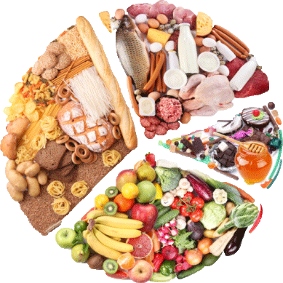

Vocab Canvas
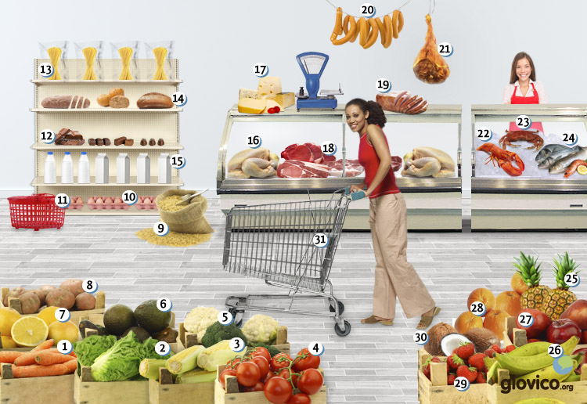

Talking

Get a reservation
You want to get a table in one of the hottest restaurants in town for Saturday night. You are lucky and get a reservation. After the dinner even the chef comes to your table and asks you about your opinion of his signature dish.

Thinking
- Think about the right kind of table (are you two persons looking for a quiet table or a group of friends who need a large table in the smoking area, etc:).
- Already think about some good arguments to convince the receptionist to give you a table in case he says the restaurant is booked out.

Talking
- Make your reservation.
- Ask about additional information such as how to get there, parking possibilites and whether you can pay with credit cards.

Optional
- Have an after-dinner conversation with the chef (were you happy with the service, did you like the food, etc.).

Story telling
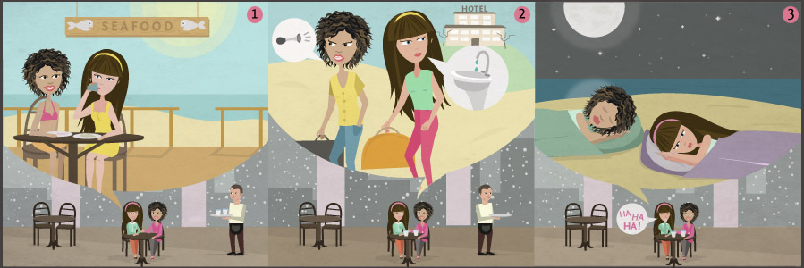

Writing

Write a restaurant review
Because your hotel review from lesson 7 was highly regarded you decide to also do a restaurant review about your favorite restaurant. Include information on their signature dish, whether the cooking caters to particular diets (like vegetarian, organic, halal or kosher), as well as your opinion of the interior and the service. Also elaborate on the pricing of the place as well as its cleanliness. Finally give the readers an idea of whether it is necessary to reserve upfront and whether there is parking available.

Preparation
- Review the vocabulary for food items.
- Consider again on how to write about the past.

Writing
- Start off by describing the food that you had.
- Give a general opinion on the restaurant (price, service, type of food, etc.).

Review
- Check your spelling.
- Check whether you have used the past correctly and whether you included a broad variety of food items.
- Once you are happy with your review, send it to your teacher so he or she can review it.

Reading

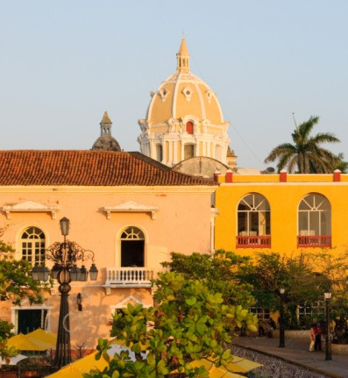

Reservar una mesa
Los padres de Pablo van a visitarlo en Cartagena, Colombia. Él está preparando un plan para su visita. Van a visitar el centro histórico de la cuidad, el barrio Getsemaní y una playa cerca de la ciudad. También quiere llevarlos a un restaurante bueno y ha elegido el "Restaurante Central".
Recepcionista: Diga.
Pablo: Hola, buenos días. Llamo para reservar una mesa.
Recepcionista: Buenos días. ¿A nombre de quién?
Pablo: Soy Pablo Vergara. ¿El restaurante está abierto el próximo domingo por la noche?
Recepcionista: Sí, desde las seis hasta las once. ¿Cuántas personas son y a qué hora quieren llegar?
Pablo: Somos tres y vamos a llegar a las ocho.
Recepcionista: Buenísimo. He hecho una reservación para el próximo domingo a las ocho para tres personas.
Pablo: Muchas gracias. Hasta luego.
Recepcionista: Hasta domingo.

Cenando en el "Restaurante Central"
Recepcionista: Buenas tardes.
Pablo: Buenas tardes. Tenemos una reservación a nombre de Vergara.
Recepcionista: Bueno. Esa es su mesa. ¿Quieren empezar con un aperitivo?
Madre: Tomo un cava.
Padre: Para mí lo mismo también, por favor.
Pablo: Entonces tres cavas.
Camarero: Por supuesto. Aquí tienen los menús. ¿Ya han estado antes en nuestro restaurante?
Pablo: Sólo yo. Mis padres no lo conocen.
Camarero: Bueno. Nuestra especialidad de la casa es el pescado con salsa de coco. Y tenemos un plato del día si quieren probar diferentes platos.
Pablo: ¿Qué van a tomar?
Madre: ¿Has visto que hay bogavante? Nunca lo he probado. Voy a pedirlo, con salsa de mariscos y una ensalada de tomates y pepinos.
Padre: Me encantaría tomar el plato del día. Hay un poco de todo: una ensalada con pescado como entrada, luego el cordero con coliflor y papas como plato principal y como postre fresas con helado.
Pablo: Voy a tomarlo también. Recomiendo el cordero, ya lo he pedido una vez, ¡es delicioso!
Después de un rato el camarero sirve las entradas.
Madre: ¡Buen provecho!
Padre y Pablo: ¡Buen provecho!
La familia está muy contenta. La comida ha sido deliciosa y han pasado unas horas divertidas en el restaurante.
Padre: Puede traernos la cuenta, por favor.
Camarero: Por supuesto.
Padre: Son 100,000 pesos. ¿Entonces pagamos 110,000 con la propina, vale?
Pablo: De acuerdo.

Culture

Inca Kola
When people think of drinks Peru you might first think of Pisco Sour. But almost as famous is a non-alcoholic drink produced in this Andean country. Selling even better than its rival Coca Cola within Peru it is available throughout Latin America and even served by some trendy bars in Europe. And while most colas around the world remain black as the original Inca Kola comes in shiny yellow as a reference to the Inca's worship of the sun.
Having been invented in 1935 and having been mostly family-owned throughout most of the time, it is still today served by many of the fast food chains in Peru. It is even sold in McDonalds and Peru was the first country where McDonalds steered away from it uniquely serving Coca Cola. In 1999 after an unsuccessful expansion which resulted in heavy debt, 50 % of Inca Kola were acquired by Coca Cola company. As the drink was marketed as an icon of Peruvian identity before that acquisition there was plenty of frustration with that move. Many local competitors entered the scene.
If you ever get a chance, give it a try. It has a uniquely fruity flavor compared to other cola and, while partly owned by Coca Cola, still transmits the feeling of Latin culture posing an alternative to mainstream globalisation.

Grammar

Expressing the recent past: haber + past participle

Past participles
The past participles in Spanish are used as part of the perfect tense (the first past tense that we will study in this lesson) or they can also be used independently as adjectives. The regular past participles are formed by adding the following endings to the verb stem.
Verbs ending in -ar | Stem + ado | hablado (spoken)
Verbs ending in -er | Stem + ido | comido (eaten)
Verbs ending in -ir | Stem + ido | vivido (lived)
There are also several verbs that have an irregular past participle. Among the verbs you have already studied the following have an irregular past participle.
abrir | abierto | opened
decir | dicho | said
escribir | escrito | written
hacer | hecho | done
ir | ido | gone
poner | puesto | put
ver | visto | seen
volver | vuelto | returned
The past participles need an accent mark when they contain one of the following combinations of vowels: ai, ei, or oi.
leer | leído | read
traer | traído | brought
escribir | escrito | written

Present perfect: haber + past participle
The present perfect is formed by using the present tense of the auxiliary verb haber and the past participle.
 | haber | past participle | English
yo | he | hablado | I have spoken
tú | has | hablado | you have spoken
él, ella, usted | ha | hablado | he, she has/you have spoken
nosotros/as | hemos | hablado | we have spoken
vosotros/as | habéis | hablado | you have spoken
ellos/as, ustedes | han | hablado | they, you have spoken
Note that the past participle is invariable when it is used in the perfect tense. Furthermore it is not permitted to separate the auxiliary verb haber and the past participle. Object pronouns and negative words are placed before the conjugated form of haber.
No he trabajado hoy. | I haven’t worked today.
La he visto esta mañana. | I have seen her this morning.

When to use the present perfect
In general you use the present perfect to express past actions or events that have some influence on the present. They have either just been completed or have taken place in a time horizon that is still ongoing (e.g., a little while ago, today, this month , this morning).
¿Has hablado con ella este mes? | Have you talked to her this month?
He trabajado cinco horas. hoy. | I have worked five hours today.
To discuss personal experiences, you can use the present perfect in combination with the words ya (already), alguna vez (already, ever), todavía no (not yet), nunca (never) .
Nunca he estado en Argentina. | I have never been in Argentina.
Has viajado alguna vez a Perú? | Have you ever travelled to Peru?

Using the past participle as adjective
Additionally you can use the past participles as adjectives. In that case the past participles agrees in gender and in number with the noun it modifies.
La puerta abierta está detrás del arból. | The open door is behind the tree.
Los postres comprados en la tienda son deliciosos. | The desserts (that were) bought in the store are delicious.
Furthermore, you can use estar in combination with a past participle to express a state or condition. In this case the past participle is also used as an adjective and agrees in the gender and in number with the noun.
Las cuentas están pagadas. | The bills is paid.
La pasta está cocinado. | The pasta is cooked.

Irregular Verbs: decir
Decir is another verbs that has an irregularity in the first person singular and additionally has a stem-change (e->i).
decir (to say)
yo | digo
tú | dices
él, ella, usted | dice
nosotros/as | decimos
vosotros/as | decís
ellos/as, ustedes | dicen
Vocbulary
Spanish | English
la fruta | fruit
la naranja | orange
la banana | banana
la manzana | apple
el melocotón | peach
el durazno | peach (latam)
la fresa | strawberry
el limón | lemon
el coco | coconut
la piña | pineapple
la verdura | vegetable
el tomate | tomato
el pepino | cucumber
el maíz | corn
el pimiento | pepper
la aceituna | olive
el aguacate | avocado
la palta | avocado (latam)
la zanahoria | carrots
la lechuga | lettuce
el brécol | broccoli
la coliflor | cauliflower
las patatas | potatoes
las papas | potatoes (latam)
los frijoles | beans
el pescado | fish
el marisco | seafood
el bogavante | lobster
la carne | meat
la carne de vacuno | beef
el cerdo | pork
el ave | poultry
el bistec | steak
el cordero | lamb
el pollo | chicken
el jamón | ham
el jamón York | boiled ham
la salchicha | sausage
el queso | cheese
el pan | bread
la mantequilla | butter
la pasta | pasta
el arroz | rice
el huevo | eggs
la leche | milk
el carrito | cart
la cesta | basket
la caja | cash register
el chocolate | chocolate
el azúcar | sugar
las golosinas | sweets
fresco/a | fresh
magro/a | lean
caliente | hot
frío/a | cold
picante | spicy
dulce | sweet
caro/a | expensive
barato/a | cheap
el zumo | juice
el jugo | juice (latam)
el té | tea
comer fuera | to eat out
cocinar | to cook
la entrada | starter
el plato principal | main course
el postre | dessert
la sopa | soup
la ensalada | salad
la salsa | sauce
el menú | menu
el plato del día | set menu
el/la camarero/a | waiter
el recepcionista | receptionist
la propina | tip
la especialidad de la casa | speciality of the house
el/la vegetariano/a | vegetarian
la comida rápida | fast food
el servicio | service
la servilleta | napkin
delicioso/a | delicious
recomendar | to recommend
el desayuno | breakfast
el almuerzo | lunch
la cena | dinner
la merienda | afternoon snack
la cuenta | bill
¡Buen provecho! | Enjoy your meal!
lo mismo | the same
el plan | plan
abrir | to open
decir | to say
romper | to break
probar | to try
la reservación | reservation
el aperitivo | aperitif
el rato | time

