Lesson 10

At Home En casa

In this lesson you learn to
- Describe your home
- Talk about household duties
- Express what is happening at the moment
- Recognize, ask about and express agreement or disagreement
- Discuss people or objects using superlatives

Vocab Canvas
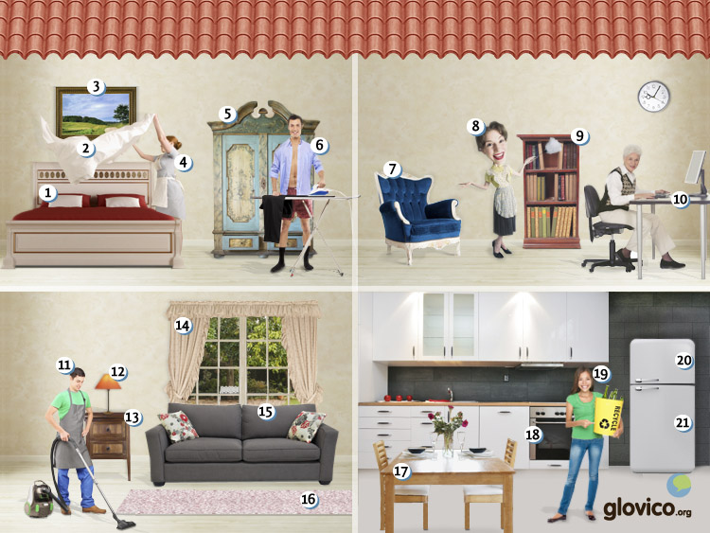

Talking

Renting an apartment
Your professor is a landlord from whom you would like to rent an appartment. Yet, the rent is a little too high for you. So you point out various shortcomings around the appartment hoping that you might be able to lower the price.

Thinking
- Take a minute to think about the things that are important for you in an apartment.
- Think about two or three shortcomings that the apartment that you are about to rent has.

Talking
- Show your interest in the apartment to the landlord without becoming overexcited about it.
- Negotiate about the price by pointing out various shortcomings (and potentially some personal things, like being a student etc.).

Optional
- Discuss whether you could share the apartment with two friends of yours.

Story telling
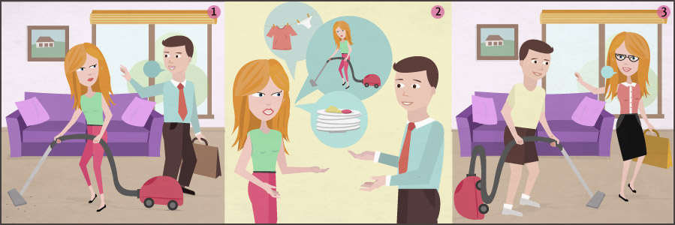

Writing

Write a letter to your landlord
You have been elected as representative of the tenants of the apartment building that you are living in. Yet, at a particular wild time as there are currently a lot of disagreements between the tenants and the landlord. You are to write a letter to the landlord explaining your discontent and offering solutions.

Preparation
- Review the vocabulary for household activities and renting an aparment
- Make a list of 3 - 5 issues that are causing the tensions between the tenants and the landlord in your apartment (e.g., the lobby is never cleaned, the common expenses are increasing too rapidly).

Writing
- Start your letter by addressing your landlord in the correct way and introduce yourself (since you were just elected he doesn`t know you well yet).
- Raise the issues that are concerning the tenants.
- Suggest a way to proceed, for example by offering your recommendations for solving the issues.
- Conclude your letter in the correct manner.

Review
- Check your spelling and whether your letter fulfills the formal requirements of a letter.
- Check whether you have used some of the structures you learnt in this lesson.
- Once you are happy with your letter, send it to your teacher so he or she can review it.

Reading

¡Qué día!
Eliana está haciendo las compras en un supermercado. Entonces suena su móvil y su vecina Mercedes llama.
Mercedes: Hola Eliana. Te llamo porque tu perro está haciendo mucho caos. Está muy sucio y corre dentro de tu salón. Lo siento pero tu casa está en completo desorden.
Eliana: ¿De verdad? Voy a tomar el camino más rápido que conozco para volver a casa. Gracias por tu llamada.
Mercedes: De nada. Hasta luego.
15 minutos después Eliana entra en su casa. Su perro está jugando con la alfombra blanca del pasillo. Está muy sucio. ¿Por qué sus hijas no están en la casa? Los jueves tienen que cuidar al perro. Ahora Eliana se siente muy enojada y empieza a escribir una lista para sus hijas: Duchar el perro, limpiar el pasillo, la cocina y el salón, pasar la aspiradora y sacar la basura.

Alquilamos un apartamento
Julia y Diego están buscando un apartamento en Santiago de Chile. Hoy tienen una cita con un agente inmobiliario.
Agente: Buenos días.
Julia: Buenos días. Tenemos una cita, porque queremos alquilar un apartamento.
Agente: Ah sí. ¿Julia y Diego Rivera, verdad?
Diego: Sí. Estamos buscando en los barrios Providencia y Ñuñoa.
Agente: Tengo diferentes apartamentos allí. ¿Quieren alquilar un apartamento amueblado?
Julia: No, tenemos muchos muebles. Preferimos un apartamento con dos o tres habitaciones.
Agente: De este tamaño tengo dos apartamentos muy bonitos y nuevos en Providencia. Podemos pasar por allí está tarde.
Diego: Me encantaría. Solamente unas preguntas. ¿Cuánto es del alquiler? ¿Y el depósito?
Agente: Pienso que el alquiler es 300.000 clp y hay un depósito de dos meses.
Julia: Vale. Nuestro presupuesto es de 350.000 clp para el alquiler y los otros gastos. ¿Cuánto es de los gastos comunes, la electricidad y el agua?
Agente: Eso depende del uso. Podemos preguntar a los alquiladores durante nuestra visita de los apartamentos cuánto pagan.
Diego: Vale. Entonces vamos a ver los apartamentos.

Culture

Mi casa es su casa
Whereas in Northern Europe or in the USA it is very common for young adults to move to their own homes in their early twenties you can see young adults living with their parents a lot longer in Latin America. As tradition holds that you do not move out until you are married you might also see people in their thirties living with their parents.
There are a number of reasons to this. On the one hand it is typically cheaper if they live with their parents. Yet, also young adults that could afford their own homes oftentimes stay with their parents. This is due to cultural reasons where the common perception is that you live with your family. And as long as you don't have a wife or husband your parents are your family.
Not surprisingly this brings along various side effects. First of all, family bonds seem to be a bit stronger than in other countries where you typically spend your adult life outside your parents' home. But it also leads - at least in some countries (Chile most notably) - to a lot more public displays of affection. If you are living with your parents while dating public parks seem to be more suitable for kissing than your home.

Grammar

Ongoing actions: gerundio
To express actions that are currently ongoing, Spanish has a construction, which is similar to the English present progressive ("I am running." or "He is walking. "). It is formed by using the present form of the verb estar as an auxiliary verb and the gerundio form of the main verb. The gerundio is formed by adding -ando/-iendo to the verb stem.
Regular -ar verbs
hablar + ando | hablando

Regular -er/-ir verbs
beber + iendo | bebiendo
Verbs that end in -ir and change their stem in the present form their gerundio in the following way.
Stem change | Infinitive | First person present | Gerundio
e -> ie | sentir | siento | sintiendo
e -> i | servir | sirvo | sirviendo
o -> ue | dormir | duermo | durmiendo
Leer and ir have an irregular gerundio.
leer | leyendo
ir | yendo
After learning to form the gerundio, you can know express that something is currently happening with the following construction.
yo | estoy | escuchando | I am listening
tú | estás | escuchando | you are listening
él/ella/usted | está | escuchando | he/she/it/you are listening
nosotros/as | estamos | escuchando | we are listening
vosotros/as | estáis | escuchando | you are listening
ellos/as | están | escuchando | they/you listening
For reflexive constructions using the gerundio the reflexive pronoun can either precede estar or it can be attached to the gerundio (similar to construction using the infinitive). If you attach it you need to add an accent.
Me estoy peinando el pelo. | I brush my hair.
Estoy peinándome el pelo. | I brush my hair.
Note that the gerundio unlike adjectives is not adapted to the gender or number of the noun.

Expressing extremes: Superlative
To make comparisons in Spanish that express that a person or an object has the highest or lowest degree of a certain characteristic within a group ("He is the smallest child in the class." or "They are the nicest people I know."), you use the superlative. There are two main constructions you can use.
el/la/los/las | más/menos | adjective | de | noun/pronoun

el/la/los/las | noun | más/menos | adjective | que | verb
Some examples that use the first construction.
Es el niño más pequeño de la clase. | He is the smallest child in the class.
Estos son los coches menos caros de la tienda. | These are the cheapest cars in the shop.
Some examples that use the second construction.
Están las personas más amables que conozco. | They are the nicest people I know.
Es la casa más bonita que conozco. | It is the most beautiful house that I know.

- See more at: http://www.glovico.org/syllabus/Spanish/lesson10/grammar#sthash.LTjbCObR.dpuf
Vocbulary
Spanish | English
los muebles | furniture
la comoda | dresser
el armario | wardrobe
la mesa | table
la silla | chair
el sofá | sofa, couch
la alfombra | carpet
la cortina | curtain
la mesa de noche | nightstand
la lámpara | lamp
el cuadro | painting
la almohada | pillow
la manta | blanket
la sábana | sheet
el basurero | garbage dump
la cocina | kitchen
el comedor | dining room
la sala | living room
el dormitorio | bedroom
el pasillo | hallway
la bodega | cellar
el désvan | attic
el garaje | garage
la terraza | terrace
hacer la cama | to make the bed
pasar la aspiradora | to vacuum
limpiar la casa | to clean the house
sacudir el polvo | to dust
lavar la ropa | to wash the clothes
secar la ropa | to dry the clothes
poner la mesa | to set up the table
sacar la basura | to take out the garbage
la lavadora | washer
la secadora | dryer
el refrigerador | fridge
el congelador | freezer
la aspiradora | vacuum cleaner
sucio/a | dirty
limpio/a | clean
sentirse (ie) | to feel
sonar (ue) | to ring
el caos | chaos
el desorden | disorder
complete/a | complete, full
rápido/a | fast, quick
el camino | road, way
el barrio | neighborhood
entrar en | to enter
cuidar | to take care of
alquilar | to rent
el alquiler | rent
el alquilador | renter, tenant
el gasto | expense
los gastos comunes | common costs (shared between renters in an apartment building)
el presupuesto | budget
amueblado/a | furnished
el depósito | deposit
el agente inmobiliario | realestate agent

